PRESS RELEASE
17 September 2021
FOR IMMEDIATE RELEASE

Tomorrow is shaped by the students of today.

Teun Zwets wins Kazerne Design Award 2021

Eindhoven – Teunland, an improvised series of household goods, was honoured on 16 September with the Kazerne Design Award 2021. Designer Teun Zwets was rewarded with everlasting fame and 5,000 euros from the jury for his project, brainchild of the designer’s prodigious creative urge. Zwets was one of the 8 nominees for the incentive prize, all of whom recently graduated from Design Academy Eindhoven.

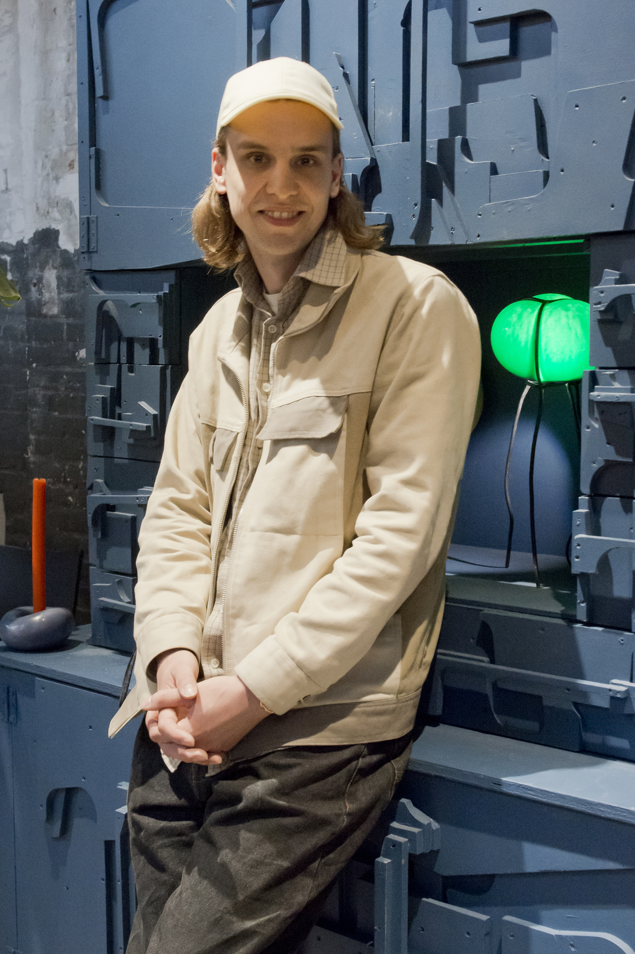
Teunland
Each of the cabinets, lamps, clocks, chairs, candlesticks, ashtrays, and vases in the Teunland series was made in less than a day by Teun Zwets, who has ADHD. He worked with materials that were available – often things others threw away – to be as sparing of time as possible and work continuously, with focus, without a daily dose of Ritalin. Zwets: ‘To me, creating is therapeutic. These objects visualise my thoughts and feelings. Creating makes me happy, and I want to make people happy with my creations.’ Focusing on the practical rather than the conceptual and on practicality rather than finish, he creates an authentic, personal world that challenges our single-use society. He chooses his materials deliberately. After all, the most sustainable designs are objects that you own for a long time.
Nominees
The eight nominees for the second edition of the Kazerne Design Award were Noor Bootsma, Miya Fassbender, Niall Keville, Benjamin Motoc, Paulien Nabben, Marie Panken, Tadeás Podracky, and Teun Zwets. They presented their final projects live and online in 4-minute pitches. The high quality of the designs, the diversity in subjects and the common theme of sustainability is striking.

Winner Teun Zwets with his cabinet made of waste materials from Piet Hein Eek.

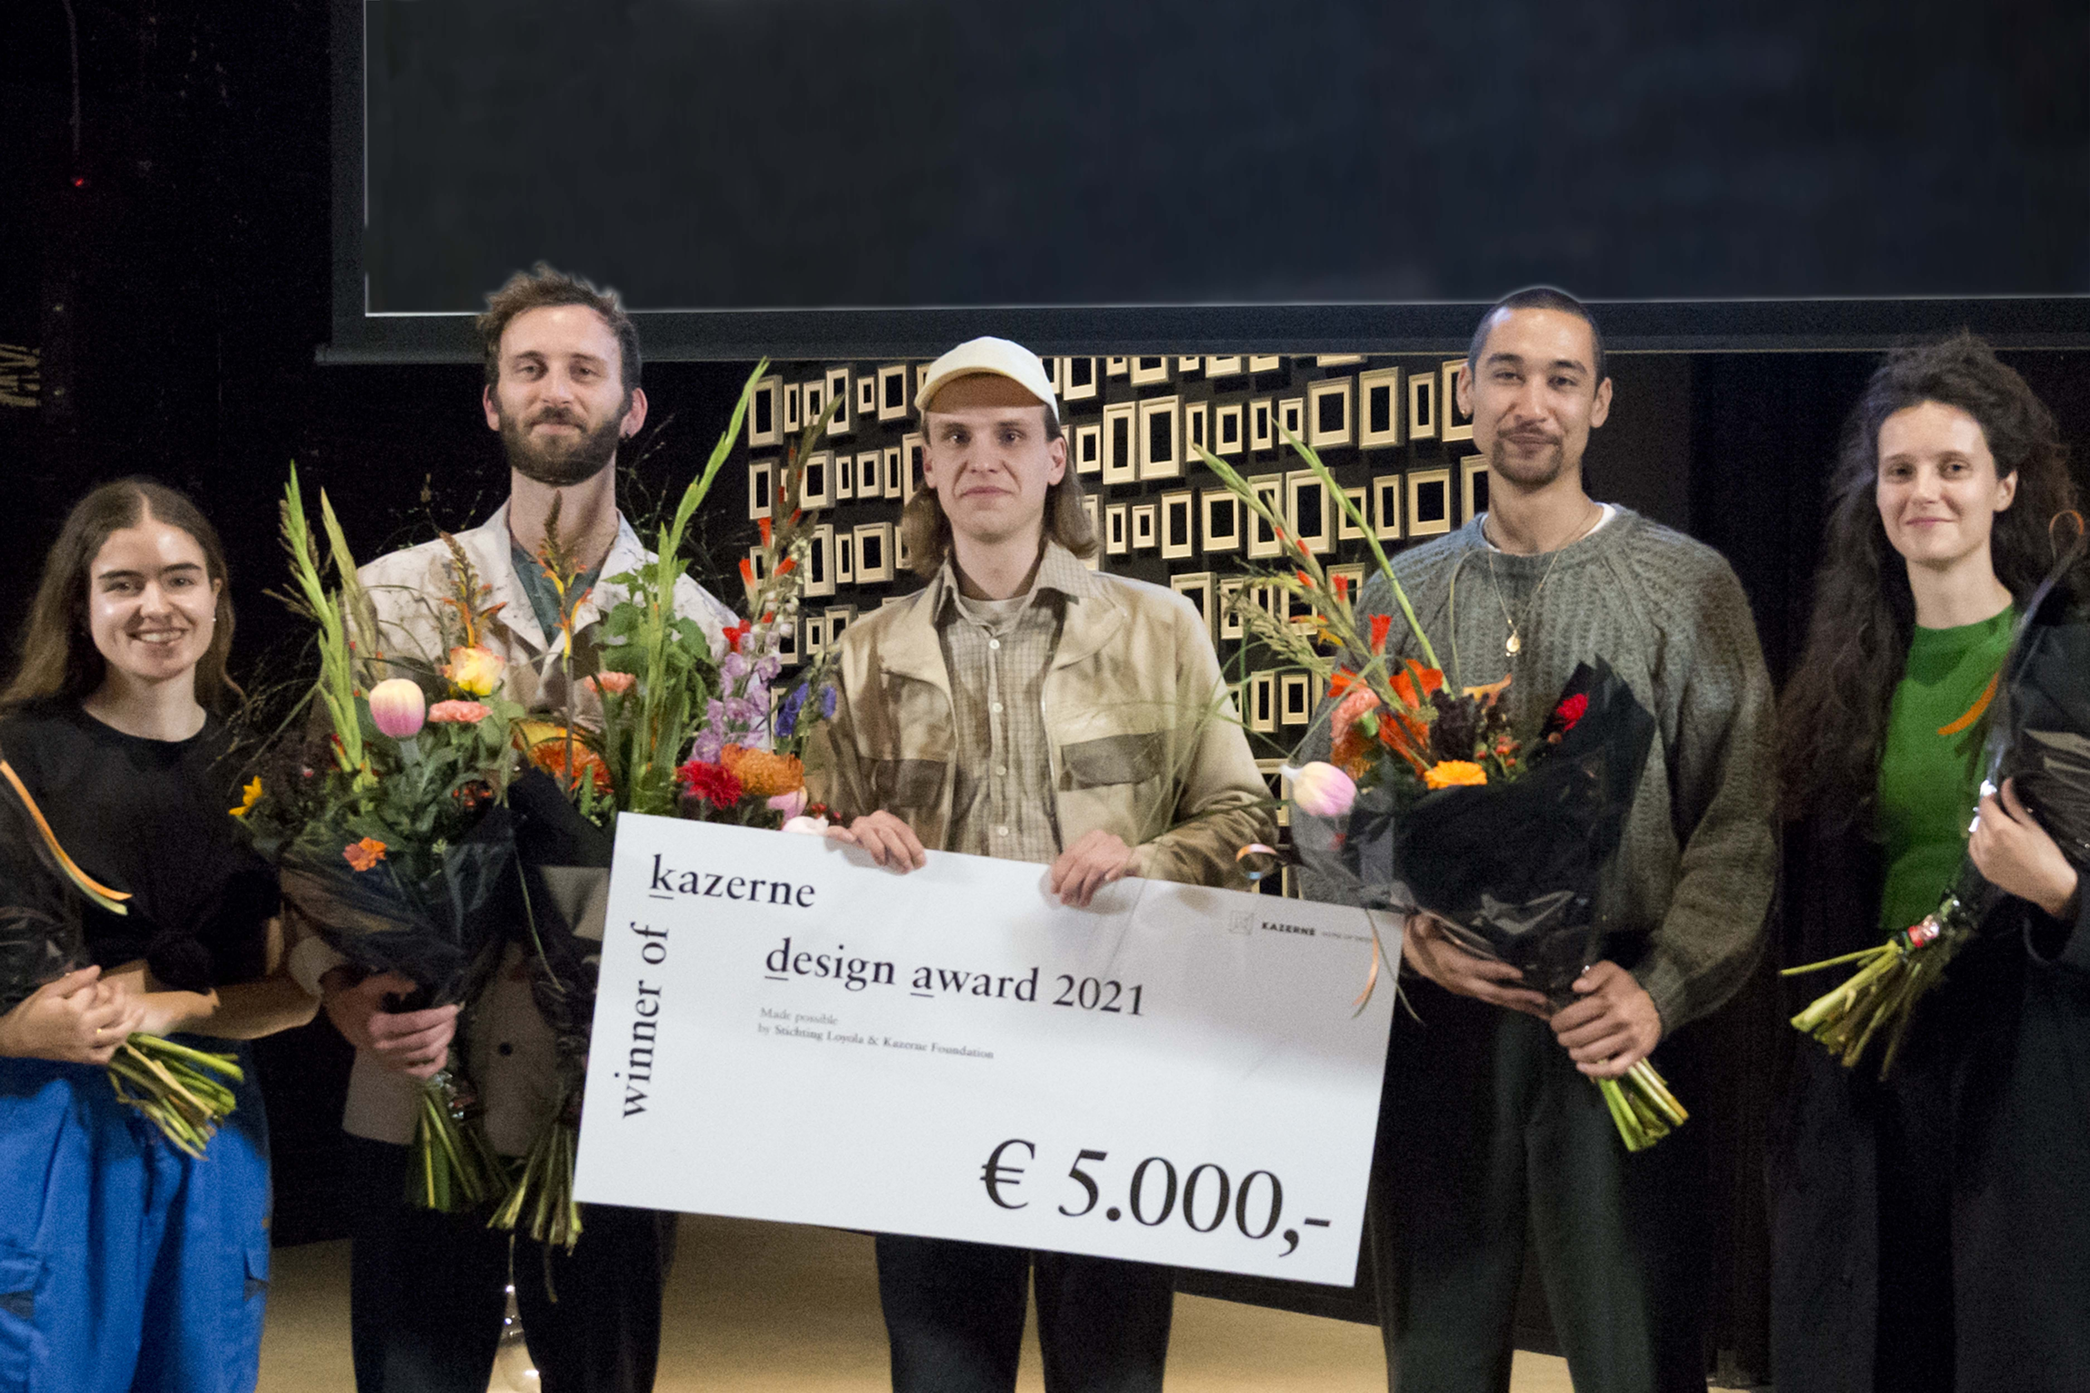
From left to right: Noor Bootsma, Niall Keville, Teun Zwets, Benjamin Motoc, Marie Panken. Nominees Miya Fassbender, Paulien Nabben and Tadeás Podracky pitched online and were not live at the Awards Show.

Pictures Ruud Balk

Kazerne Design Award 2021
The Kazerne Design Award is an annual incentive prize for designers who recently graduated from Design Academy Eindhoven. It is an initiative of the Loyola Foundation, together with Home of Design Kazerne. The jury, consisting of Kiki van Eijk (Kiki and Joost), Annemoon Geurts (Kazerne), Anne Ligtenberg (Studio Anne Ligtenberg), and the board of the Loyola Foundation, chose Zwets' work after extensive deliberation. Van Eijk: ‘Teun's project is particularly relevant now as the world is becoming increasingly digital, particularly in the last year and a half. His project and presentation concern creation and improvisation. Today’s uncertain situation calls for people who can improvise. His project includes many ideas that he can continue to develop in the years to come.’

Selection criteria were authenticity, creativity, execution, and relevance of the designs in combination with an engaging pitch. Jury member Geurts: ‘At first, it was difficult to choose the nominees, because there was no Graduation Show last year and we had to rely on digital information. We considered it important that a study or concept was actually developed into a good design. The evening itself was filled with excitement until the last minute because of the diversity of the pitches and projects. How do you assess the practically executable concept of Noor Bootsma, which takes community gardens as a model for protecting oceans, versus the beautifully executed sculptural furniture pieces by Benjamin Motoc, versus the professional, poetic, presentation with dancing letter shapes by Niall Keville? Each in their own right interesting concepts and talented designers. At Kazerne, we are curious about the next step in their careers. We will follow all eight of them eagerly.’

See for yourself
The Kazerne Design Award show can be viewed via the Kazerne YouTube channel. The Kazerne Design Award exhibition will be on display at Kazerne in the centre of Eindhoven until spring 2022 (end date to be confirmed). Here, visitors can eat, drink and spend time surrounded by the exhibition. Free admission and WIFI, guided tours on request. Open daily 12:00 – 00:00

Kazerne –Home of Design
Paradijslaan 2-8, 5611 KN Eindhoven
T + 31 40 207 37 30
www.kazerne.com

Home of Design Kazerne
Based in former military barracks and adjoining industrial warehouse, Kazerne celebrates the impact of design by welcoming guests to eat, drink and sleep surrounded by recent works by world-class design talents. Renovated with great attention to its original beauty, the heritage has 2,000 square metres of exhibition space (with exhibitions changing every six months), that include eight luxury hotel rooms and lofts, several meeting rooms, a design shop and two restaurants: the industrial bar/restaurant with Italian and fine-dining Restaurant Benz at Kazerne, with Vintage French touch. Imagine a museum like platform, against a backdrop of monumental heritage, that has been transformed into a breath-taking hotel.

“This is where guests meet the local creative community. Here, in an inspiring environment, conversations about the contribution of design to a more human world of tomorrow take place naturally", explains co-initiator and Creative Director Annemoon Geurts.

@KazerneEhv

NOTE TO THE EDITOR - not for publication

For more information about the presented works, designers and interview request, please contact:

Kazerne
Annemoon Geurts +31 (0)6 22529413, media@kazerne.com

Free-of-copyright, high-resolution images are available upon request.
See also: https://kazerne.com/en/press-releases/

Please let us know if you are working to a deadline.

