PRESS RELEASE
3 September 2020

Shaakira Jassat wins first Kazerne Design Award
Tomorrow is shaped by the students of today
Eindhoven – Tea drop, a project about sustainable water usage was honoured with the first Kazerne Design Award on 3 September 2020. Shaakira Jassat, born in Africa, was chosen by the jury as the winner, receiving eternal fame and 5.000 euro for a project that successfully contributes to the awareness of Western water waste. Jassat was one of the 10 nominees for the prize meant to encourage recently graduated students of Design Academy Eindhoven.

Tea Drop
From irrigation to packaging to cleaning: it takes 30 liters of water to produce one single cup of tea.
By capturing the water for a cup of tea drop by drop via condensation – a process that could take days – Tea Drop questions our Western available-on-demand lifestyle. Jassat: “Tea drop is a speculative design to start the conversation about the hidden water usage. With the prize money, I can further concretize the potential of my project Aquatecture, a research into water harvesting machines.”

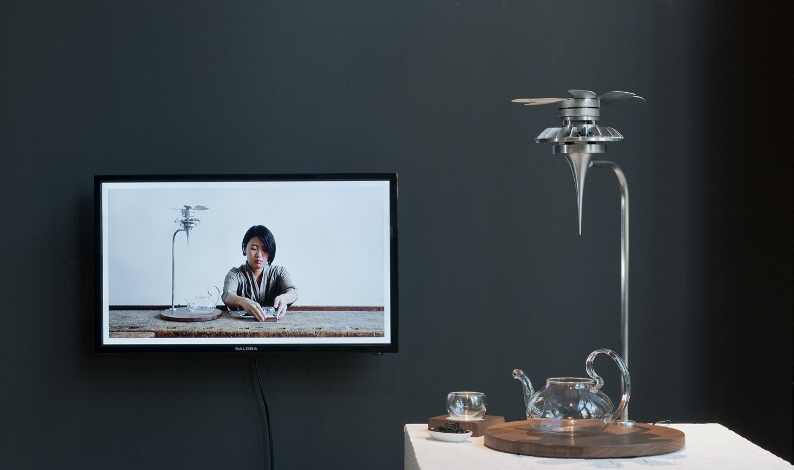

Nominees
The Kazerne Design Award is a new yearly prize meant to encourage recently graduated students from Design Academy Eindhoven. An initiative by Stichting Loyola, together with Home of Design Kazerne. The 10 nominees – Yarden Colsey, Pauline Esparon, Shaakira Jassat, Fides Lapidaire, Romain Laval, Clara le Meur, Leo Orta, Mies Raadgever, Federico Rosa and Lucas Zito – presented their graduation project live and online in 3-minute long pitches. Remarkable is the high quality of the designs and the common theme of sustainability.

Kazerne Design Award 2020
The jury, consisting of Kiki van Eijk (Kiki & Joost), Lonneke Gordijn (Studio Drift) and Annemoon Geurts (Kazerne) chose unanimously for the work of Jassat. “A layered project, with vision, poetic and mindful”, says Lammie Nijsingh, chairman of Stichting Loyola, that provided the prize money.

At the end of the evening, Kiki van Eijk revealed that she, together with her partner Joost van Bleiswijk, want to offer one of the nominees space in their studio to exhibit their work during Dutch Design Week. They selected Romain Laval, with his work The Ceramic Blob Factory.

See for yourself
It is possible to rewatch the award show via the Kazerne YouTube channel. The exhibition, with the work of all nominees is on show until the end of September. Home of Design Kazerne is open daily from 12:00, to view the exhibition, for lunch and dinner. Entrance and Wi-Fi free.

www.kazerne.com.

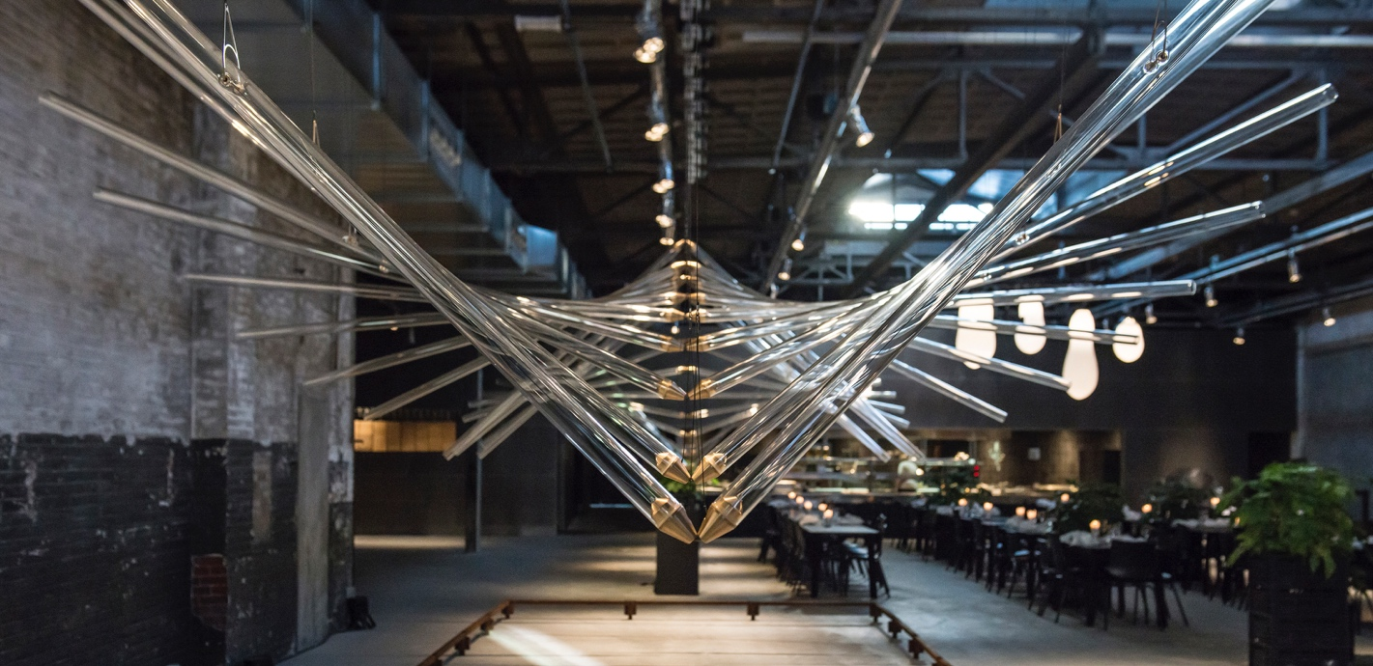

ABOUT KAZERNE
Based in former military barracks and adjacent industrial warehouse, Kazerne celebrates the impact of design by welcoming guests to eat, drink and sleep surrounded by recent works by world-class design talents. Renovated with great attention to its original beauty, the heritage has 2,000 square metres of exhibition space (with exhibitions changing every four months), that include eight luxury hotel rooms and lofts, several meeting rooms, a design shop and two restaurants. The industrial Bar/restaurant with Italian touch opened in 2014. The new fine-dining Restaurant Benz at Kazerne, with a Nordic touch, opened in 2019. Imagine a museum like platform, against a backdrop of monumental heritage, that has been transformed into a breathtaking hotel.
"This is where guests meet the local creative community. Here, in an inspiring environment, conversations about design take place naturally", explains initiator and Creative Director Annemoon Geurts.

NOTE TO THE EDITOR — not for publication
Online press folder
Press release and free of rights high-res images: http://kazerne.com/en/press2/
Complimentary images and designer biographies are available upon request.
Contact
For more information on the exhibited works, designers and interviews:
call +31 (0) 40 207373, +31 (0)6 22529413 (Annemoon Geurts) or send an e-mail to media@kazerne.com.

