INVITATION
We are pleased to invite you to the exclusive Kazerne Design Award show in Kazerne in Eindhoven, Thursday 3 September from 7:30 PM to 9:00 PM. In addition to the nominees, the jury will also be present. We would like to hear in advance if you would like a personal interview. This is possible, for example, from 4:00 PM or after the show.
RSVP
See you then!
Kind regards, Annemoon Geurts and Koen Rijnbeek
KAZERNE, PARADIJSLAAN 2-8, 5611 KN EINDHOVEN
Kazerne is within walking distance of the Eindhoven railway station. There are several parking garages in the area. Click here for our directions.

PRESS RELEASE
31 August 2020

New award for young design talent
KAZERNE DESIGN AWARD 2020
Tomorrow is shaped by the students of today.
Eindhoven – On September 3 2020 the first Kazerne Design Award will be presented: an incentive prize for recent alumni of Design Academy Eindhoven. The jury grants the lucky winner eternal fame, an exhibition of the nominated work and 5,000 euros to get started.
Nominees are Yarden Colsey, Pauline Esparon, Shaakira Jassat, Fides Lapidaire, Romain Laval, Clara le Meur, Leo Orta, Mies Raadgever, Federico Rosa and Lucas Zito. The jury consists of Kiki van Eijk (Kiki and Joost), Lonneke Gordijn (Studio Drift) and Annemoon Geurts (Kazerne). The prize is sponsored by Stichting Loyola.
The Award show, including presentations by all nominees, can be watched live via Kazerne's YouTube channel. The exhibition can be visited until the end of September. Home of design Kazerne is open daily from 12:00 to view the exhibition, for lunch and dinner. Free access and wifi.
www.kazerne.com.

NOMINEES

Yarden Colsey – Old dog new tricks

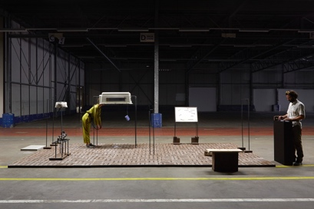
Dogs are trained in the Netherlands and deployed in conflict zones in other countries, such as Israel and Palestine. Old Dog New Tricks is an interactive sound installation that draws parallels between the training of dogs and people for war zones. Participants undergo a parcours on a custom training ground. With a stick between their teeth, they hear a narrative about how man and his four-footed friends are conditioned for conflicts.

Yarden Colsey is an Israeli/British designer based between Israel and Europe. His work often stands in direct connection to his roots, Jerusalem: a city built upon layers of ancient ruins left with reminisces of different times. The city is continuously repurposed by whoever tries to rule it. In his work, Yarden builds up something by having disturbed something, striping down a mechanism from its original function and repurposing it.

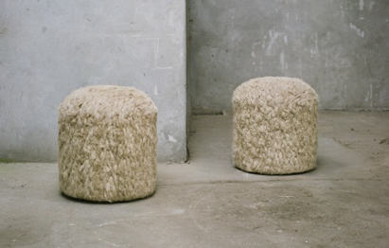
Pauline Esparon - L’échoucheur
While growing and being scutched in Europe, 80% of flax nowadays has to be exported to China to be combed, spun and woven before being reimported. This situation contradicts the sustainable growth of the fiber and the need for locally produced materials. By working directly with the scutched fibers, this project aims to present new aspects, tactilities and properties of linen, whilst encouraging and diversifying a local network of production, based in Normandy.

In her work, Pauline Esparon plays with the primary state of materials before they are standardized by industry. Her works always start with the investigation of materials, sliding from an instinctive research to a definite shape. She questions both the qualities of materials and their culture; heritage, survival and systems. Her projects envision a proposition to tweak production for the better and new possible perspectives for crafts.

Shaakira Jassat – Tea Drop

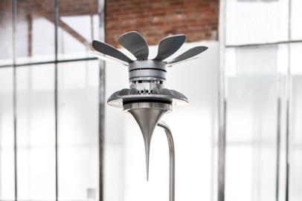
From irrigation to packaging to cleaning: it takes 30 liters of water to produce one single cup of tea. On a symbolic level, Tea Drop recaptures this resource, whilst giving power back to the environment: the tea machine condenses water vapour from the surrounding air. In contrast to our available-on-demand lifestyle, one has to wait for the tea vessel to be filled with water, before it can be boiled to make tea.

Shaakira Jassat is a graduate of the Man and Food Department. Born and raised in South Africa, she now lives in the Netherlands. Her work is influenced by her upbringing in the young democracy of South Africa and het former profession in the field of interior architecture. Her research methods range from being on and off field all the way to multidisciplinary experimental research.

Fides Lapidaire – Broodje Poep

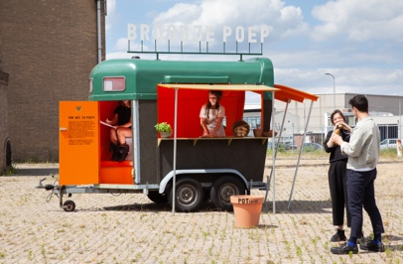
Broodje Poep is a sandwich made from ingredients grown on human poop and pee compost. The sandwiches are sold at festivals from a food truck. By integrating a dry toilet to collect human waste into the design of a caravan that serves tasty sandwiches, Broodje Poep demonstrates how easy it is to close the food cycle.

As a social designer, Fides Lapidaire offers surprising perspectives on complex issues. She dares to not get a point, looks where you might think there is nothing to find and exposes pressing questions. As a result, she creates an environment where processes of awareness arise that trigger change.

Romain Laval – The Ceramic Blob Factory

Efficiency was a basic idea behind the Industrial Revolution. While efficiency is very practical, the chain of consequences have crushed diversity and reduced life to an endless repetition of the same processes. The Ceramic Blob factory presents a production line with inefficiency, randomness and chances. It underlines the normality of mistakes, diversity and human error, revealing the absurdity of the industrial process.

Romain Laval prefers to visualise his thoughts rather than writing them. Creating by doing is an essential part of his process. He puzzles the research by gathering a lot of visual media, either in series of film or images. Romain prefers the poetic storytelling side of design, and he constantly seeks to trigger the viewer’s imagination and perception of reality.

Clara le Meur – Valuable Gesture Factory

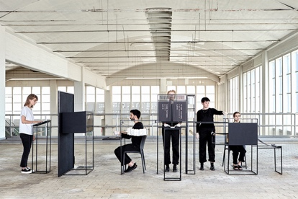
The luxurious, unique weaves produced by the Valuable Gesture Factory visualise the hidden economy behind our screens. Activity on the Instagram account of the factory is harvested by an algorithm that generates patterns for punching cards.
These ‘user patterns’ are processed by a jacquard loom - an analogue ancestor of computer programming - producing the weaving pattern. The new textile – containing clicks, likes and comments – becomes a physical trace of the value generated with our data.

Clara Le Meur is a French designer and artist based in Paris. She graduated Cum Laude from Design Academy Eindhoven. Her interest lies in the exploration and questioning of the phenomena of interaction between users and artifacts, the tangible and the immaterial, the visible and the hidden, from the past and the future. She mixes mediums and technologies of various times and places and translates ideas that sprout from her research into objects, materials, installations and sounds.

Leo Orta – Creatures of Retention

Creatures in Retention is based on the continued possession and our personal relationship to fast consumer goods. As the global recycling circuit is still not functioning optimally, high-consumer objects have a huge impact on our environment. Reflecting on their life-cycle, the Lion-dogs are shaped to represent the frightening reality of our consumption. They are here to remind us that a spirit is still to be found in objects we throw away.

Leo Orta lives and works between Paris and Les Moulins, France. His work focuses on the social links that human beings establish with identity through consumption and their personal relationships with nature. It encompasses a large variety of media including sculpture, installation, and performance. Leo's work already has been presented at the FRAC in Paris, at K11 in Guangzhou and the Museo Marino Marini in Florence, at the Design Museum Gent.

Mies Raadgever – The Hole Trap

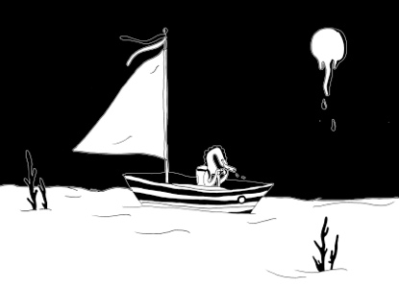
Dive into the world of Nam, Woe and Leav: a fictional place that shows how we are threatening our world. We all know that pollution is an enormous threat to the continued existence of life on Earth. We want to do something, but don't know how. The scale of the problem is simply too big. Shrinking the situation into pages of a book can help us connect with reality again.

Through her work, that – amongst others – encompasses illustration, photography, animation and objects, Mies Raadgever invites spectators into her world of thought. She takes urgent, present-day topics out of their context by translating them into her own imaginary world. In this way, she stimulates the viewer to look at topics from a different perspective.

Federico Rosa – Acqua Alta

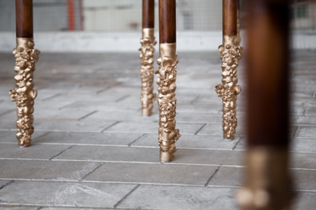
While the furniture of Acqua Alta may look classic and traditional, it actually carries an alarming message. As the sea level is rising, floods in Venice get worse. Water is entering houses and restaurants, but still there is no solid policy to save the city. The pieces revive awareness by reflecting the effects of high tide; remnants like mollusks, barnacles and seaweed become casted ornaments for their legs. More than ever, in these COVID coloured days, we are confronted with the impact that water has on Venice.

Federico Rosa is a 26-year-old designer and photographer from the cozy streets of Venice, Italy. Growing up playing around with his father’s cameras, he developed an everlasting love for film photography. Niches and their issues have always fascinated and inspired Federico. With his design he address those often-overlooked themes, suggesting reflections, opinions and possible solutions.

Lucas Zito – Filter Loop

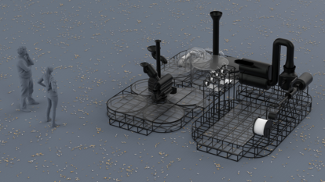
What if cigarette butt litter was valuable rather than destructive? Filter Loop features a modular, mobile recycling machine, designed to be installed in key pedestrian spaces in large cities. It enables passengers to gather cigarette stubs for recycling, in exchange for 3D printed products and goods, created directly on site with the recycled material cellulose acetate.

Lucas Zito's work manoeuvres between design philosophies that have been gaining weight in the last decade. He believes that we can create better models to implement ideas and solutions into society. Our societies’ systems are often quite meticulous and theoretical. This allows us to anchor solutions to real problems and to reach to many gears of the contraption we are living in.

JURY

Kiki van Eijk is one of the most accomplished names of Dutch Design, together with her partner Joost van Bleiswijk. Her world is whimsical and colorful, lyrical and personal, yet refined by skillful craftsmanship.
Annemoon Geurts is the founder and creative director of home of design Kazerne. Here she celebrates the worldwide impact of her design colleagues by bringing the value of design for the world of tomorrow to the public, in welcoming heritage.
Lonneke Gordijn is half of the celebrated designduo Studio Drift. Their work is a quest for balance in the relationship between human/nature/technology, and is exhibited worldwide at leading museums, art fairs and institutes, such as Kazerne.

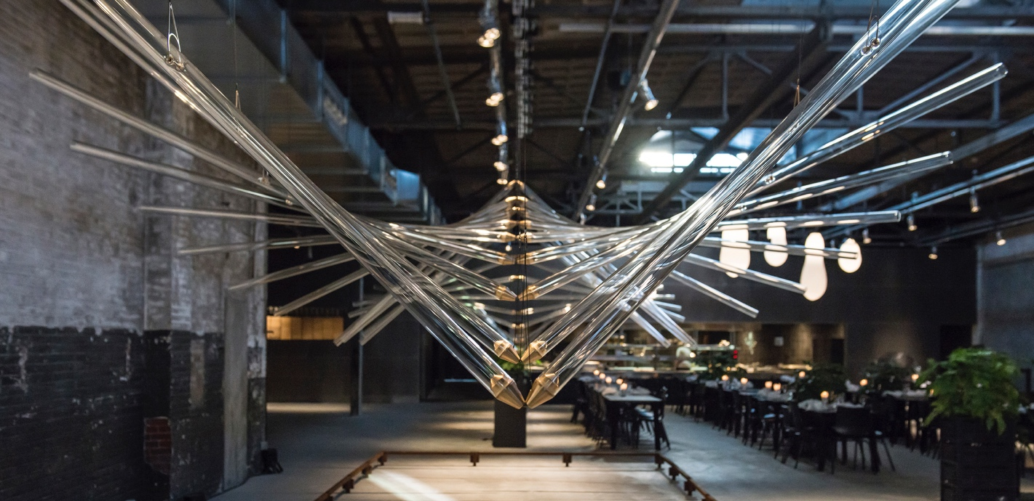

ABOUT KAZERNE
Based in former military barracks and adjacent industrial warehouse, Kazerne celebrates the impact of design by welcoming guests to eat, drink and sleep surrounded by recent works by world-class design talents. Renovated with great attention to its original beauty, the heritage has 2,000 square metres of exhibition space (with exhibitions changing every four months), that include eight luxury hotel rooms and lofts, several meeting rooms, a design shop and two restaurants. The industrial Bar/restaurant with Italian touch opened in 2014. The new fine-dining Restaurant Benz at Kazerne, with a Nordic touch, opened in 2019. Imagine a museum like platform, against a backdrop of monumental heritage, that has been transformed into a breathtaking hotel.
"This is where guests meet the local creative community. Here, in an inspiring environment, conversations about design take place naturally", explains initiator and Creative Director Annemoon Geurts.

NOTE TO THE EDITOR — not for publication
Online press folder
Press release and free of rights high-res images: http://kazerne.com/en/press2/
Complimentary images and designer biographies are available upon request.
Contact
For more information on the exhibited works, designers and interviews:
call +31 (0) 40 207373, +31 (0)6 22529413 (Annemoon Geurts) or send an e-mail to media@kazerne.com.

