MEDIA RELEASE
10 March 2020

New exhibition in Home of Design Kazerne
The Circle – Dutch Invertuals
“The ultimate symbol of infinity, unity and perfection."
In the exhibition The Circle, the Dutch Invertuals collective focuses on one of the most iconic shapes in our universe. Over 25 leading designers, including Nina van Bart, Satomi Minoshima, Baiba Soma, Bram Vanderbeke, Nel Verbeke and Jeroen Wand (both up-and-coming and established talent), show their personal vision on the mother of all forms. In 2019, The Circle was already on show during Salone del Mobile in Milan and the DutchDesign Week in Eindhoven. Complimented with new works, the exhibition is now on show for a longer period of time than a festival week in Home of Design Kazerne, right at the heart of design city Eindhoven.

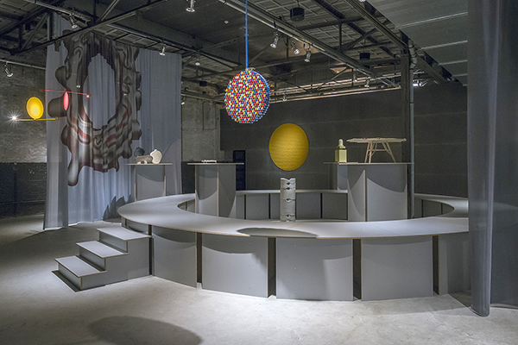
About The Circle
"In times of division and inequity, the circle stands as an emblem of co-operation and connectivity. We need to go back to the origin to find out what is fundamental in life. Interpreting the circle pushes each Invertuals to identify what is essential to them." -says curator Wendy Plomp. She asked the designers to redesign the circle.
The personal visions on the mother of all forms show a rich diversity of autonomous design; from conceptual to practical designs and from philosophical to mathematical. The exhibition design by Daphna Laurens also uses the shape as a basis. Visitors can level with the work from a round podium. Together with the monumental curtains, this walkable circle sheds light on the industrial exhibition space of Kazerne.
About Dutch Invertuals
Led by Wendy Plomp, the collective Dutch Invertuals have been presenting themselves for ten years during international design festivals. In the exhibition in Kazerne, a selection of Dutch Invertuals designers is on show, under which up and coming and established talents like Architects of Identity (Edhv), Daphna Laurens, Raw Color and Martens & Visser, that have been playing an important role in the collective for years.
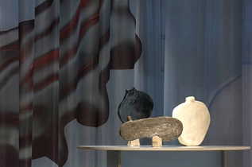
The circle as a primitive shape
Inspired by the earliest application of the circle as a vessel, Willem van Hooff designed the serie Core. He makes use of prehistoric African techniques. The works are physically balanced and simultaneously question the idea of the perfect circle.

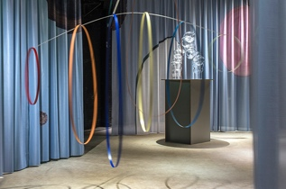
Reality and gravity
Internal and External Forces consists of a mobile of bouncy materials, that in theory could form the perfect circles. However, this seems like an unlikely scenario in this dynamic, chaotic world. The movement and interaction appeal more to Max Lipsey than the idea of the perfect circle.

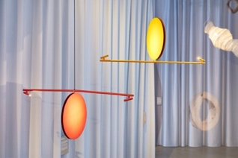
A mathematical approach to the circle
According to Wikipedia, the term 'circle' refers to both the inside of the figure as well as the boundary and its interior together. Technically the edge is called a circle and the whole figure is called a disk. With Open Disk, Daphna Laurens brings a mathematical ode to the shape that designers owe so much to.

The exhibition The Circle is on show till June
Kazerne is open daily from 12:00 till midnight. Visitors can eat, drink, work and relax surrounded by the exhibition. Entrance and Wi-Fi are free, tours on demand. Kazerne is located at Paradijslaan 2-8, Downtown Eindhoven, The Netherlands.
The Circle Features: Architects of Identity (Edhv), Nina van Bart, Daniël de Bruin, Amandine David, Willem van Hooff, Studio Joachim Morineau Daphna Laurens, Max Lipsey, Carlo Lorenzetti, Martens & Visser, Satomi Minoshima, Raw Color, Dorian Renard, Schimmel and Schweikle Tijmen Smeulders, Baiba Soma, Jelle van Twillert, Bram Vanderbeke, Nel Verbeke, Jeroen Wand

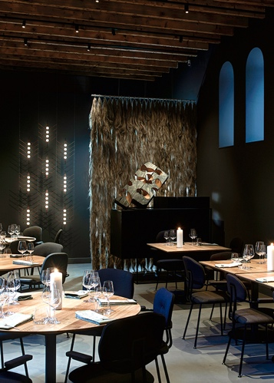
ABOUT KAZERNE
Based in former military barracks and adjacent industrial warehouse, Kazerne celebrates the impact of design by welcoming guests to eat, drink and sleep surrounded by recent works by world-class design talents. Renovated with great attention to its original beauty, the heritage has 2,000 square metres of exhibition space (with exhibitions changing every four months), that include eight luxury hotel rooms and lofts, several meeting rooms, a design shop and two restaurants. The industrial Bar/restaurant with Italian touch opened in 2014. The new fine-dining Restaurant Benz at Kazerne, with a Nordic touch, opened in 2019. Imagine a museum like platform, against a backdrop of monumental heritage, that has been transformed into a breathtaking hotel.
"This is where guests meet the local creative community. Here, in an inspiring environment, conversations about design take place naturally", explains initiator and Creative Director Annemoon Geurts.

NOTE TO THE EDITOR — not for publication
Online press folder
Press release and free of rights high-res images: http://kazerne.com/en/press2/
Complimentary images and designer biographies are available upon request.
Contact
For more information on the exhibited works, designers and interviews:
call +31 (0) 40 207373, +31 (0)6 22529413 (Annemoon Geurts) or send an e-mail to media@kazerne.com.

