PRESS RELEASE
October 2019
————————————————————————————————————————————————
New exhibition in Home of Design Kazerne:
CIRCULAR > MATERIALISTS.
Sustainable design: contradictio in terminis?

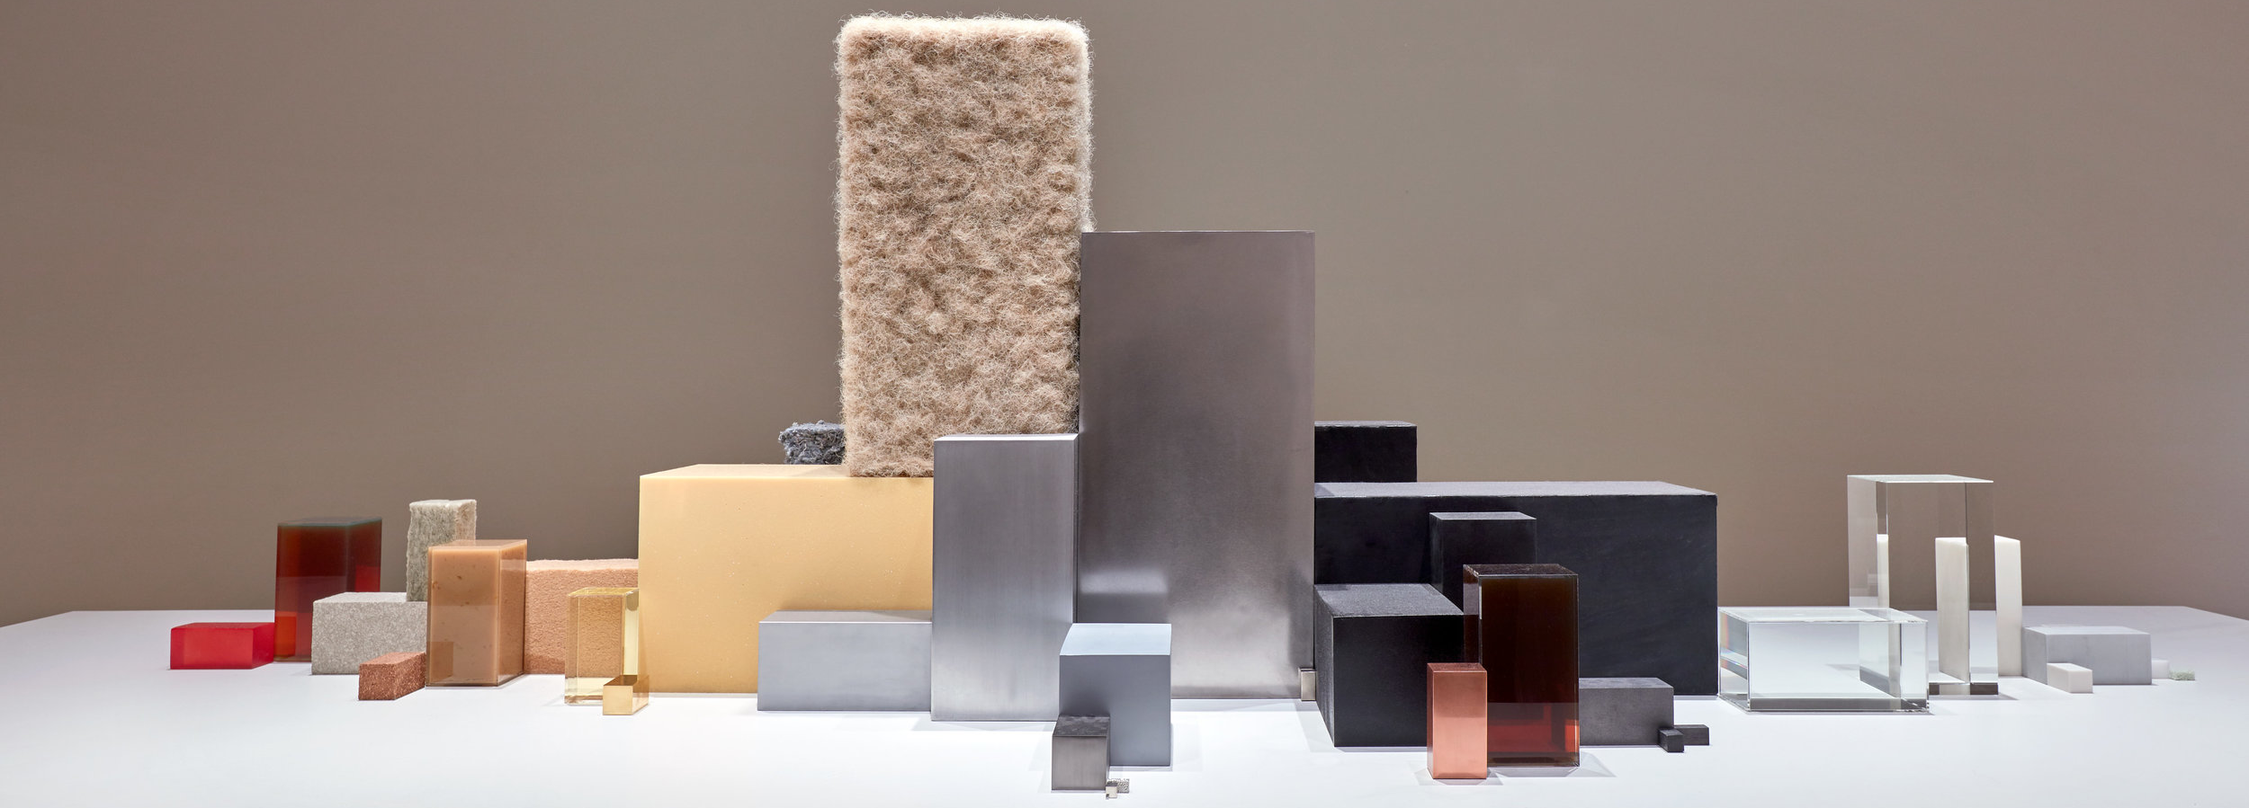
The exhibition Circular>Materialists. investigates how designers tackle the fundamentally contradicting topic of sustainable design. With over 40 works from both leading and promising designers, amongst whom: Sigi Ahl for Eileen Fisher (curated by Lidewij Edelkoort) Studio Dirk vander Kooij, Benjamin Motoc, Studio Drift and Baiba Soma.
Volkswagen Beatle by Studio Drift

EINDHOVEN — With a hopeful look at the future, and an eager eye towards the role of design in it, on the first Saturday of the Dutch Design Week 2019 (DDW), Kazerne opens the new exhibition: CIRCULAR> MATERIALISTS. The exhibit is partly accommodated in the previous military police barracks that have been renovated with lots of respect for the beauty of the heritage. Since March guests are able to eat, drink, meet, work and even sleep surrounded by world-class design exhibitions. Here and in the adjoining industrial warehouse that opened in 2014, from October 19 visitors encounter top design that revolves around the theme of sustainability. Amongst the participants are both established names and promising talents — as you can expect from Kazerne. Studio Dirk vander Kooij presents his Buitenhuis Chandelier, Beer Holthuis extrusions from the world’s first Paper Pulp Printer, Baiba Soma her graduation project, Studio Drift the breathtakingly meticulous blocks of Materialism, Benjamin Motoc a delicate yet imperishable series of cast metal sculptures. Furthermore, the very topical installation Waste No More from Sighi Ahl, curated by Lidewij Edelkoort for Eileen Fischer is on show. Hence, Kazerne is once more one of the DDW hotspots to get inspired by the design of tomorrow.

In the exhibition
Design is a materialistic phenomenon. And that’s a challenge, as good design today has to be responsible. Hence designers focus more and more on different ways to produce and use assets, like re-using old- or developing new - sustainable - materials. They experiment with new (or old) production techniques, they play with scenarios for the future, and question practices from the past. The exhibition CIRCULAR> MATERIALISTS. shows how both accomplished labels and starting designers tackle the fundamentally contradictory theme of sustainable design.
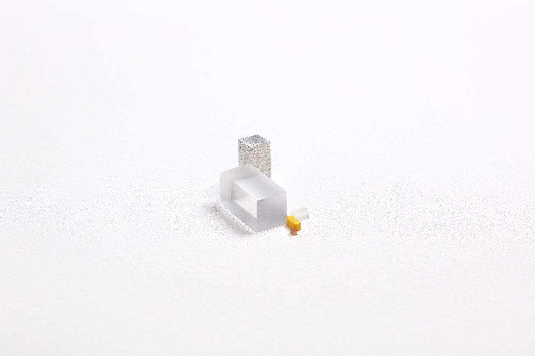
Sculptures or reverse engineering
Materialism confronts us on a very elementary level with the things we surround ourselves with every day – and the materials that comprise them. The work calls for contemplation: on how we deal with the raw materials at our disposal. Everyday products like a vacuum cleaner, Volkswagen Beetle, pencil, or an LED light have been reduced to the exact quantity of the specific raw materials from which they are made – shown in the form of rectangular blocks.
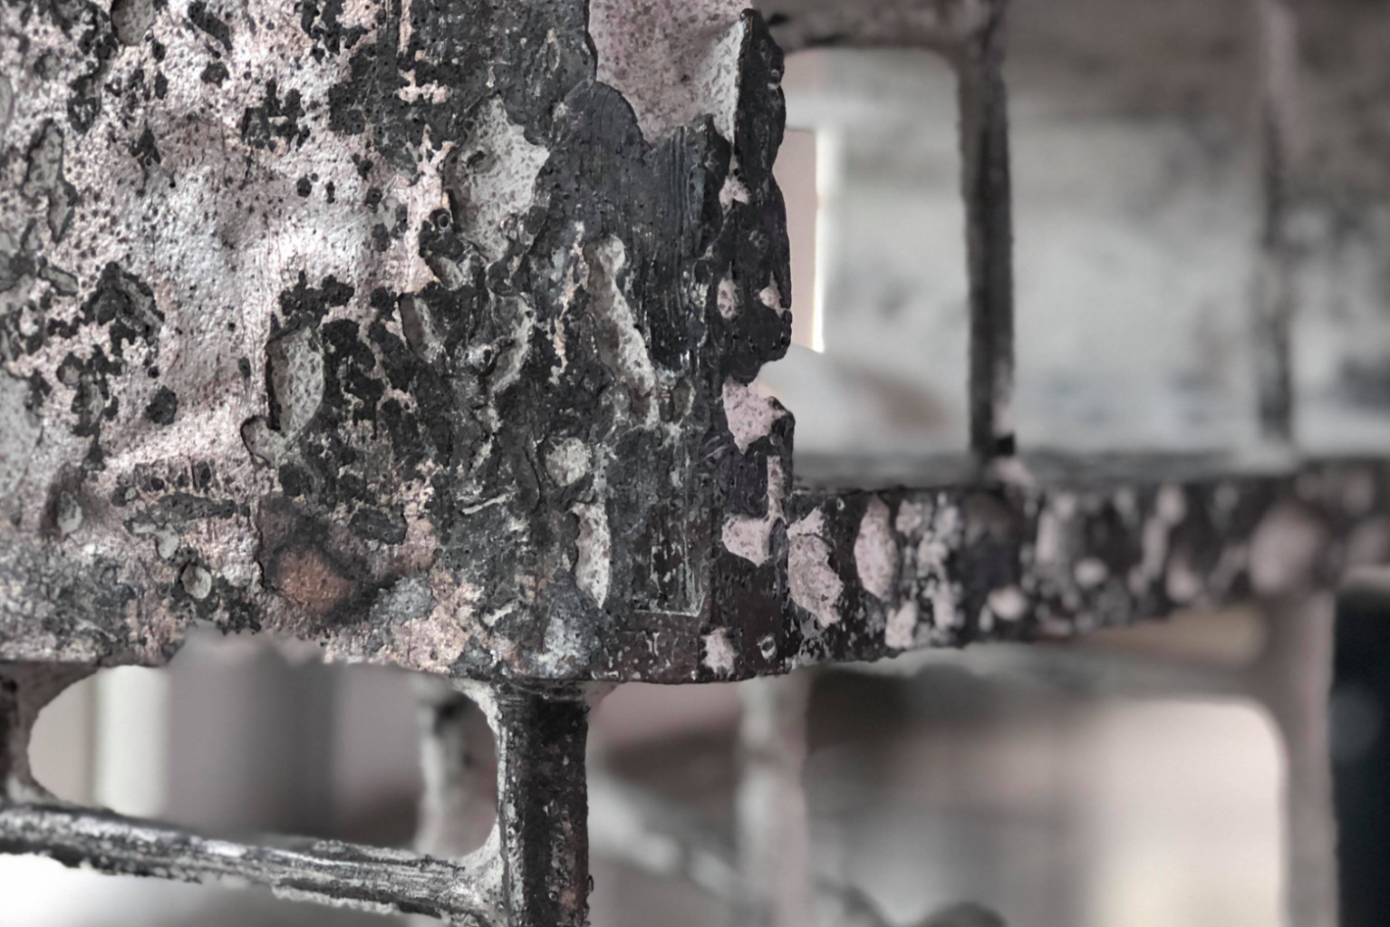
An intriguing research into the practice of casting metal
When wax is replaced by bronze and aluminium, Kron, Syull and Ktus become depictions of delicate yet imperishable details that visualize the process of metal casting. Visible and invisible spaces fade into each other in cyclical order - an honest process, with materials that don’t degrade. Supported by channels that the metal is poured through, the aesthetics and balance of the objects create a dynamic design that is in close conversation with its production. Benjamin Motoc is a name to remember.
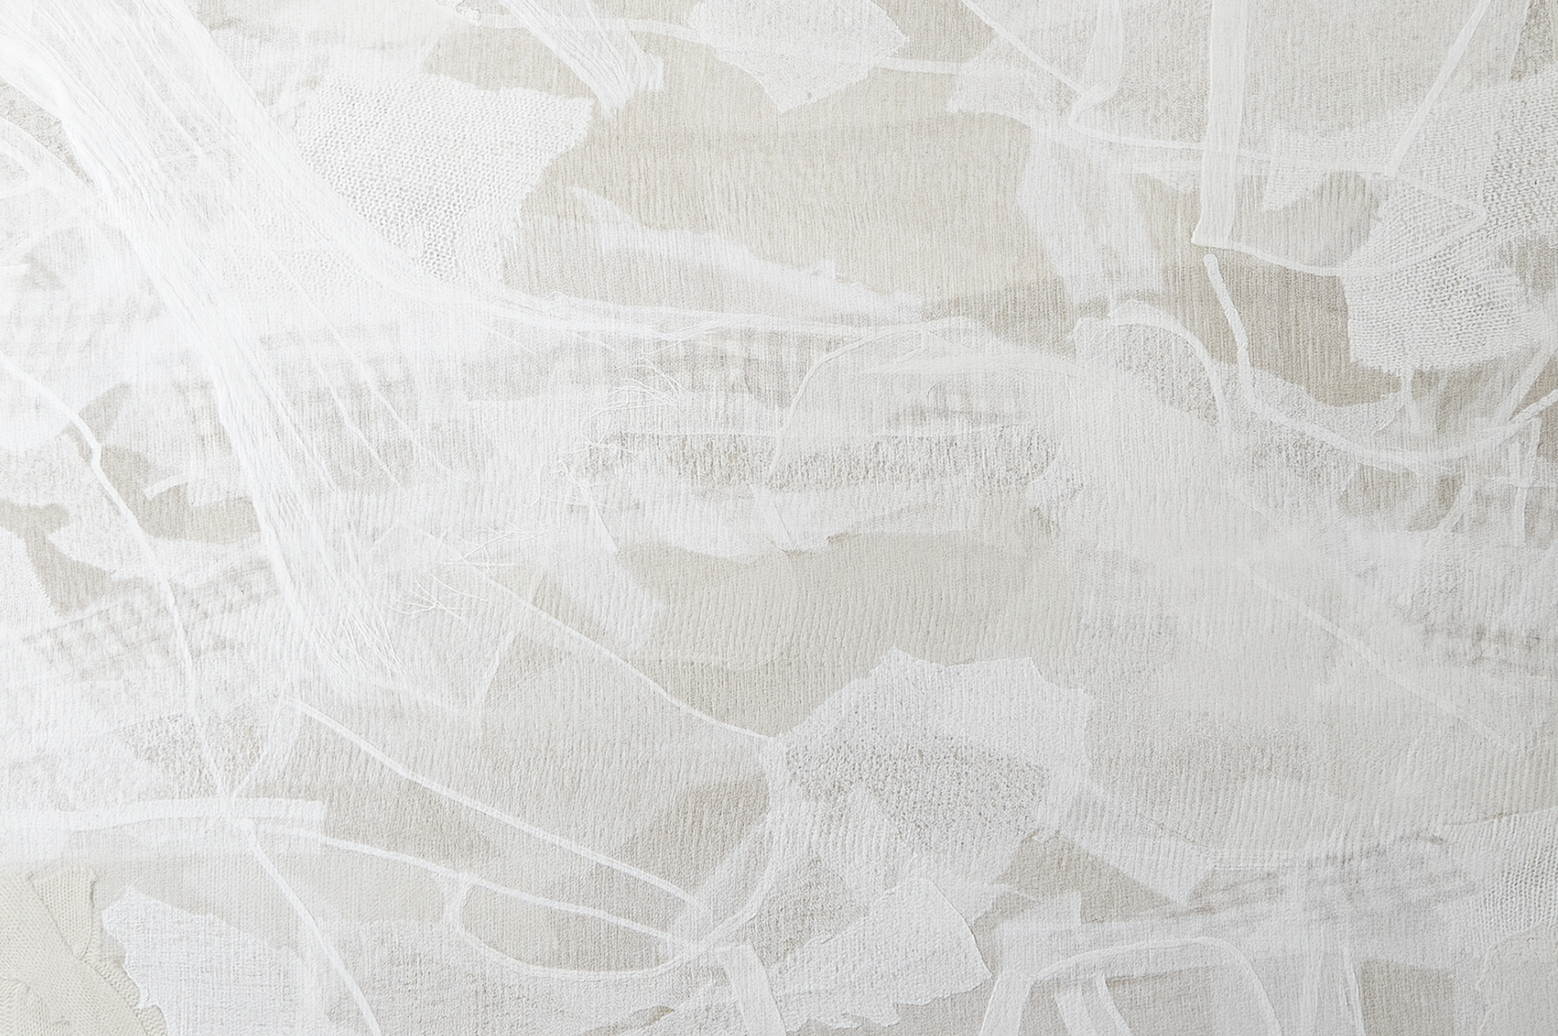
Waste no More, curated by Lidewij Edelkoort
In 2009, Eileen Fisher started a take-back program, collecting over 1.2 million garments. Led by creative director Sigi Ahl, the Waste No More studio transforms the most damaged pieces into unique art pieces, wall hangings, pillows and accessories with a custom felting technique – that uses no colouring or water. Waste No More is an initiative to help us move towards a zero-waste, high-design future.

CIRCULAR> MATERIALISTS. features Theodora Alfredsdottir & Daniel Durnin for Thomas Eyck, Maarten Baas x SDK Vastgoed, Théophile Blandet, Matilde Boelhouwer, Chardé Brouwer, Daniel Costa, Les Couleurs Suisse x Rado, Studio Drift, Aleksandra Gaca, Fransje Gimbrère, Sebastian Guzman Olmos & Nils Ahrenberg, Sander Hagelaar, Beer Holthuis, Jeroen Junte, Joshh& Thomas Eurlings, Joshh& Visser & Meijwaard, Jupe by Jackie for Thomas Eyck, Billie van Katwijk, Dirk vander Kooij, Shahar Livne, Studio Maarten Kolk & Guus Kusters for Thomas Eyck, Modular, Benjamin Motoc, Studio Nando, Fabio Novembre x Lensvelt, Ontwerpduo, Simone Post, Gerrit Rietveld x Forbo, Baiba Soma, SOM Tales of Perfume, Caterina Tioli, Pauline Wiersema & Thieu Custers, Victoria Yakusha x Faina, Hozan Zangana
Art Direction: Annemoon Geurts

WASTE NO MORE features Sigi Ahl for Eileen Fisher, curated by Lidewij Edelkoort

DDW 19 t/m 27 oktober 2019
Kazerne endorses the DDW 2019 theme ‘If not now, then when?' from its mission to continuously bring the role and the value of design to the public. The exhibition CIRCULAR> MATERIALISTS. about the fundamentally contradicting theme of sustainable design underlines this once more. A theme that is not just in the spotlight because of the urgent calls of the younger generations. During DDW, aside from the new exhibition, visitors will get the chance to see the renovated heritage, which was completed last March.

During Dutch Design Week, both the exhibition and the restaurants are opened daily from 11:00h. The exhibition closes at 20:00h, except for the exhibition in the restaurant and the meeting rooms, which are opened until midnight.

Eat & Drink
Design and hospitality concept Kazerne now houses two restaurants.

In the industrial bar/restaurant Kazerne chef Giovanni Gabana and his team give an authentic yet modern Italian touch to the menu. In the midst of a world-class design exhibition, they serve robust and no-nonsense dishes.
You can visit for a delicious lunch, a refreshing aperitif or a complete dinner. For example: an espresso with homemade chocolate truffles, bubbles with oysters, or a freshly made pasta with a salad and a wine pairing. A 3-course menu starts at 37 euro.
New: fine dining in Benz at Kazerne. Intimate, exclusive and sophisticated. Here, 24 year old talent chef Rasmus Olander offers a unique culinary experience with a Nordic touch. In the coach house of the former military police barracks (where the first motorised fire truck d’n Benz was parked), he takes you on a light, yet earthy and bright, yet elegant gastronomic adventure. Immerse yourself in a world full of wine, dine and design.

About Kazerne
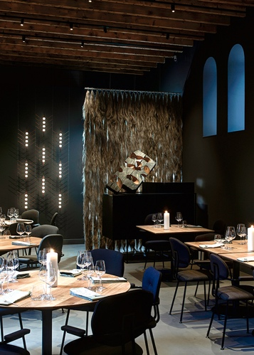
Eindhoven, an important city within the international design field, now offers a unique design and hospitality experience: Kazerne - Home of Design.
Located in former military police barracks (Kazerne in Dutch) and an adjacent industrial warehouse, Kazerne celebrates the impact of design by welcoming guests to eat, drink and sleep surrounded by recent works by world-class design talents. Renovated with great attention to its original beauty, the heritage building has 2,500 square metres of exhibition space (with regularly changing exhibitions), that includes eight luxury hotel rooms and lofts, several meeting rooms, a design shop and two restaurants. The industrial Bar/Restaurant with an Italian touch opened in 2014. The new fine-dining Restaurant Benz at Kazerne, with a Nordic touch, opened in March 2019. Imagine a museum like platform, against a backdrop of monumental heritage, that has been transformed into a breathtaking hotel. “This is where guests meet the local creative community. Here, in an inspiring environment, conversations about design take place naturally”, explains Creative Director Annemoon Geurts. Like no other Kazerne offers an environment where guests can experience 24/7 how design adds value to the world we live in.

————————————————————————————————————————————————
NOTE FOR EDITORS — not for publication

Vernissage October 19th 17:00h
We would like to invite you to the exclusive press preview on Saturday October 19th at 17:00h. You are more that welcome for a viewing of our new exhibition CIRCULAR>MATERIALISTS. Alongside founder and creative director Annemoon Geurts, several designers will be present. We’d love to hear up front whether we can arrange a personal interview with Annemoon and/or one of the exhibiting designers.

Kick off Kazerne Design Award 19 oktober 17:30 uur
Chairwoman Lammie van der Els of Loyola Foundation will introduce the Kazerne Design Award Introduceren, a prize to encourage Design Academy Graduates that will be awarded in tspring 2020.

KICK THAT ASS award October 19th 17:40h
This award is meant to encourage starting designers, and was created in 2016 by designer Maarten Baas, who will be there to hand out the. You are welcome to join.

Online press kit
Press release and high-res images (free of rights): http://kazerne.com/press
Additional images and designer bio’s available on request.

Contact
For more info on exhibited work, designers and applications for interviews:
call +31 (0) 40 207373, +31 (0)6 22529413 (Annemoon Geurts), or mail to media@kazerne.com

