MEDIA RELEASE
29 April 2019

New exhibition HOPE in home of design Kazerne

Hopeful design, curated by Ilse Crawford & Oscar Peña

Hope is a state of action. And effort is one of our most powerful catalysts for change. There is an optimistic message at the heart of the group exhibition on HOPE in home of design Kazerne in Eindhoven, the Netherlands: that small changes can make big differences. The hopeful projects are designed by students, past and present, from the Design Academy Eindhoven departments led by curators Ilse Crawford and Oscar Peña.

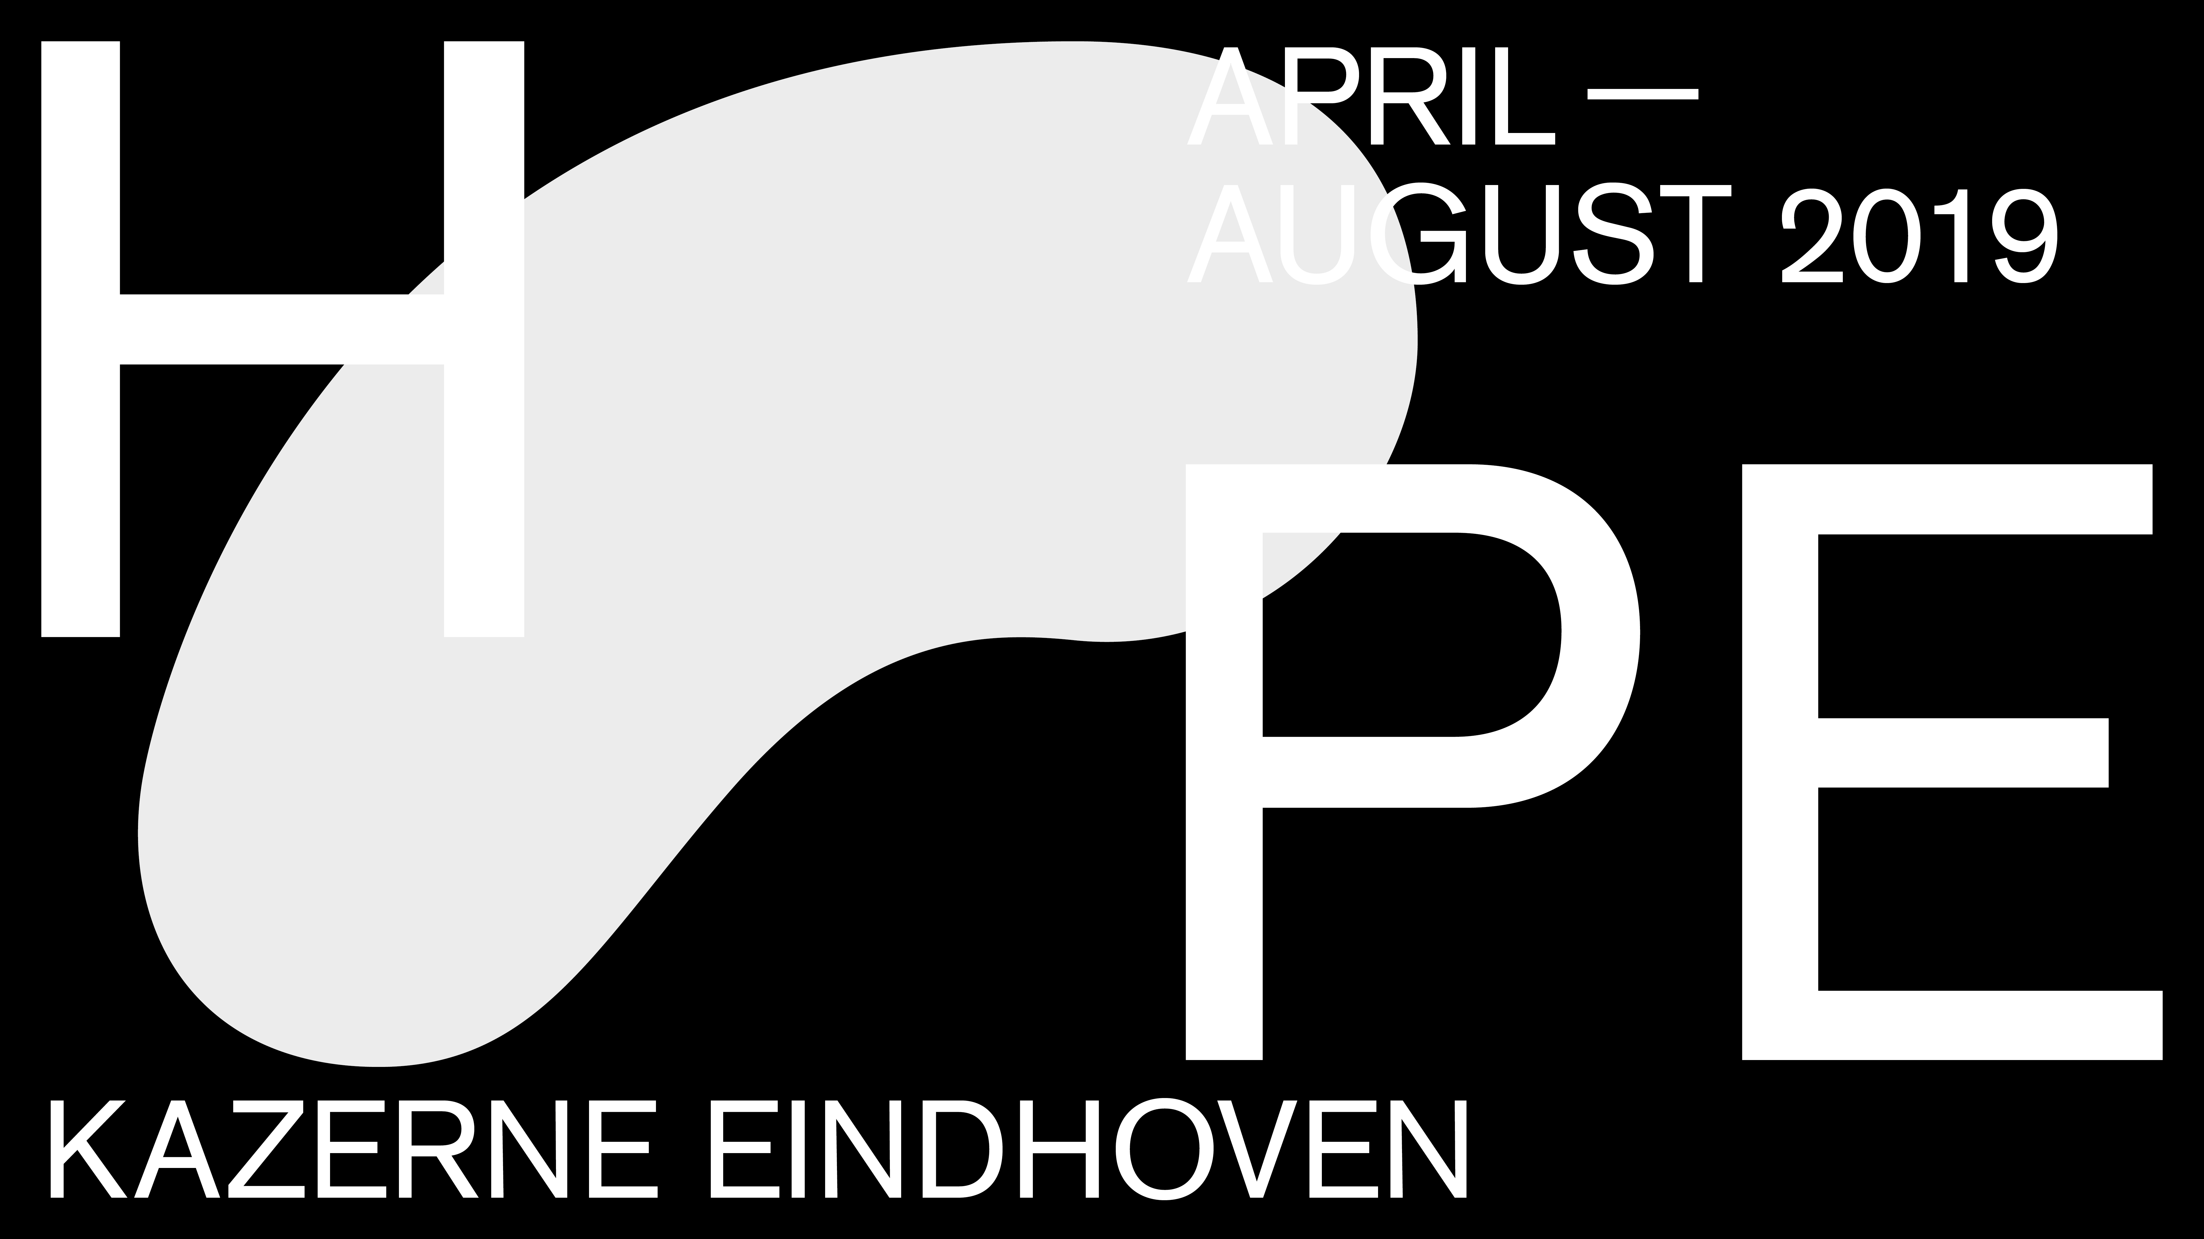

Hopeful design
Hope is a state of action. And effort is one of our most powerful catalysts for change. There is an optimistic message at the heart of our group exhibition on HOPE: that small changes can make big differences. Each of the exhibited projects – from Design Academy Eindhoven (DAE) students, past and present – is hopeful. In some cases, they offer hopeful solutions for specific aspects of local and perhaps personal concern. In others, hope comes from proof that a good idea can infect a system at an industrial, and even global scale. Importantly, the projects did not set out to change the world top down. They started with ideas to address issues immediately at hand. They offer glimmers of inspired thinking about how we might look at ourselves, our lives and our practices through a different lens, in a different light. A powerful aspect of life today is how fast good – not just bad – ideas can spread This is hopeful design.

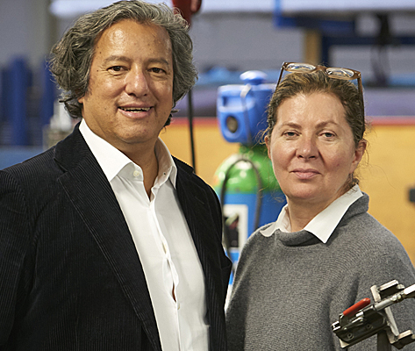
Crawford and Peña leaving DAE
The group exhibition HOPE at Home of Design Kazerne is a celebration of the DAE departments led by Ilse Crawford and Oscar Peña. Ilse Crawford, the founding head of DAE’s ‘Man and Well-Being’, is also founder of Studioilse, where she has pioneered the power and potential of wellbeing values in design across brands, spaces, furniture and objects. Co-curator Oscar Peña, head of ‘DAE’s Man and Activity’, is a creative director, industrial product designer and co-principal of Studioilse. Ilse and Oscar just announced to leave DAE at the end of this season, after leading the departments for more than 20 years, guiding over 1.200 students into becoming professional designers.

Crawford and Peña: “It is too easy today to feel hopeless. Our many crises and failures are well-documented and weigh heavy. Many of us feel there is nothing we can do to help improve our various self-inflicted predicaments. This is not the case. A hopeless attitude only self-perpetuates our feeling of inertia. In reality, effort is one of our most powerful catalysts for change. If hopelessness is a state of mind, then hope is a state of action. We are almost deaf to the cry that small changes can make big differences, but we would be wise not to write this statement off as an empty cliché just yet. A powerful aspect of life today is how fast good – not just bad – ideas can spread. Consider how far our attitudes towards plastic, meat and gender have shifted in just a couple of years. It is a radical notion that we do not need to fix everything to fix something. We can be in control of the new realities we face - whether on a personal, community or global level - if we choose to be. Let’s hope we do.”

3 Themes
The exhibition is divided in three themes: Careful Tech, Local Authority and Being Well. As in every Kazerne exhibit, work of both upcoming and established talents is on show.

Careful Tech explores technology as a fascinating catalyst that touches nature, craft, ethics, biology, health and sustainability to create to a more humane world. With her project 5000times for instance, the upcoming talent Isabel Mager visualizes the hidden labor within the production chain of laptops. She portrays the paradox that arises in ICT, by showing the manual actions that one production employee performs in one day, often under appalling conditions. The project gives hope that awareness of the human face of production will change our attitude to overconsumption. The famous duo Studio Formafantasma breathes new life into an old technique, designing water containers from pig's bladder. Craftica gives hope that we will optimize creatively éverything from a slaughtered animal - from head to tail - including fish skins and animal waste.

Globalization imposes systems that homogenize, with little regard for the sometimes centuries-old local culture or characteristics. The design displayed within the Local Authority context is empowering people and communities with solutions that are relevant to their own specific context. Dave Hakkens, for instance, brings his childhood dream Kamp to the attention. This offline community will be self-sufficient and collaborating on social challenges, such as making plastic recyclable for everyone. The project gives hope by facilitating communities to create local solutions to their problems. The recently graduated Colombian designer Simón Ballen’s together with the local community and a glass blower of the Marmato region, built an oven to produce glass objects from a waste product of gold that used to be discarded into the river. The project Orfebre gives hope that waste products can also benefit and give pride to those that mine them for others.

Being Well addresses the critical importance to de-institutionalize our approach to life and death and to restore the human value in illness and wellness. How is it possible for instance, that people swallow vitamin D en-masse to compensate for a lack of sun, but at the same time pollute the oceans with tiny particles of sunscreen which leads to the dying of coral? This research question resulted in the development of new manners of sun protection: the Sun+ collection of Buro BELéN (who were also responsible for the exhibition design). Brigitte Coremans’s biodegradable Paper coffins for still born babies give hope that they can be respected as human beings instead of treated as medical trash. This project taps into the topicality of a just recently changed Dutch law, enabling parents to register their dead born baby; an important recognition and ritual to support the mourning process.

Designers sharing optimism
Kazerne’s founder and Creative Director Annemoon Geurts is Alumnus of the DAE department Man and Identity: “More and more design is in the spotlight as one of the driving forces in reinventing our society. Because at Kazerne we operate explicitly from a design perspective, we share the fundamental optimism of the designer. Often the impossible turns out to be possible, simply because the designer won’t take no for an answer. That’s why we are thrilled to show our visitors the hope that derives from the works and perspectives presented in this new exhibition.”

The HOPE exhibition is on show till September.
Kazerne is open daily from 12:00 to midnight. Visitors can also enjoy coffee, lunch, drinks and dinner. Entry to the exhibition and Wi-Fi are free of charge. Kazerne is located at Paradijslaan 2-8, 5611 KN Eindhoven, The Netherlands.

For more information, please visit www.kazerne.com

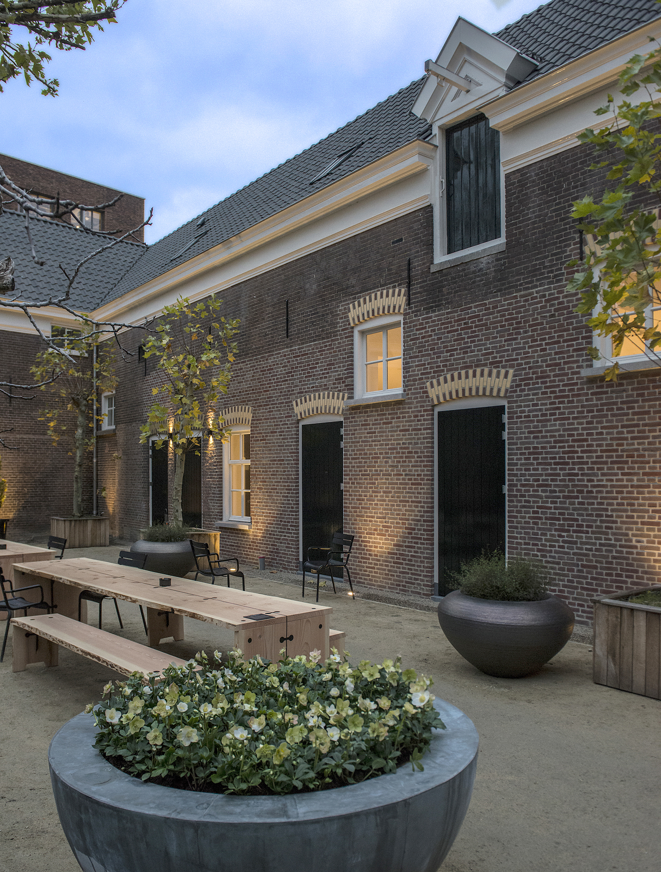
ABOUT KAZERNE
Eindhoven, an important city within the international design field, now offers a unique design and hospitality experience: Kazerne - Home of Design. Located in former military police barracks (Kazerne in Dutch) and an adjacent industrial warehouse, Kazerne celebrates the impact of design by welcoming guests to eat, drink and sleep surrounded by recent works by world-class design talents. Renovated with great attention to its original beauty, the heritage building has 2,500 square metres of exhibition space (with regularly changing exhibitions), that includes eight luxury hotel rooms and lofts, several meeting rooms, a design shop and two restaurants. The industrial Bar/Restaurant with an Italian touch opened in 2014. The new fine-dining Restaurant Benz at Kazerne, with a Nordic touch, opened in March 2019. Imagine a museum like platform, against a backdrop of monumental heritage, that has been transformed into a breathtaking hotel. “This is where guests meet the local creative community. Here, in an inspiring environment, conversations about design take place naturally”, explains Creative Director Annemoon Geurts. Like no other Kazerne offers an environment where guests can experience 24/7 how design adds value to the world we live in.

HOPE features: Alissa + Nienke, Clémence Althabegoïty, Atelier NL, Émilie Bordes x Yoon Seok-hyeon x Chae Soowon, Simón Ballen Botero, Buro Belén, Nicolette Bodewes, Aurore Brard, Mirjam de Bruijn,
Nacho Carbonell, Brigitte Coremans, Teresa van Dongen, Envisions, Pauline Esparon, Formafantasma, Dave Hakkens, Nienke Helder, Olivier van Herpt, Mirl van Hoek, Studio Mieke Meijer, Studio Joachim Morineau, Bas Kamp, Amenda Kelders, Agne Kucerenkaite, Don Yaw Kwaning, Anne Ligtenberg, Isabel Mager, Sabine Marcelis & Brit van Nerven, Tamara Orjola, Reineke Otten, Eva Oyevaar, Mathilde Philipponnat, Madeleine de Pontevès, Sanne Ree Barthels, Martin Sallieres, Renee Scheepers, Leo Schlumberger, Makiko Shinoda, Ines Sistiaga, Pieter Städler, Stone Cycling, Super Local, Pascale Theron, Daan Veerman, Elin Visser

NOTE FOR EDITOR - not for publication

Press release and royalty-free high-res images can be downloaded via: http://kazerne.com/en/press
Additional images and interviews are available on request. Please contact Annemoon Geurts via mail to communications@kazerne.com

