Media Release

from international creative industries platform Kazerne, Eindhoven, The Netherlands
20h February 2015

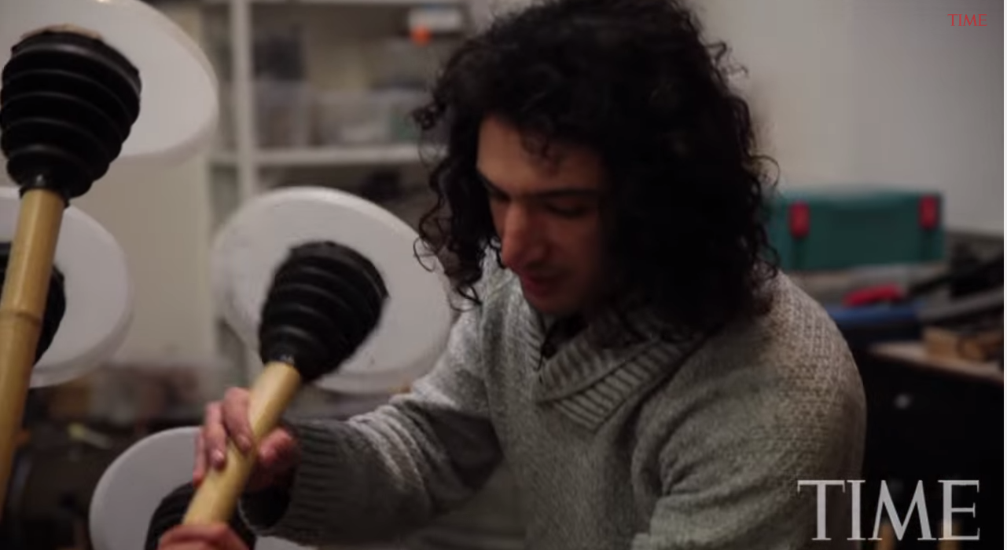

Gallery KAZERNE: OPEN WORLD

The second exhibition within the OPEN theme opens soon

Designing a better future – without landmines

As international troops pull out of Afghanistan, they leave behind a lethal legacy of unexploded bombs and shells. Around 10 million landmines still contaminate more than 500 square kilometres of land. They are still killing and maiming people at a rate approaching 400 a year. The vast majority of the victims are children.

Sadly the situation in Afghanistan is not unique. There are another countries like Angola, Iraq, Cambodia and Bosnia where the continued presence of millions of landmines brings daily misery to families living in the legacy of conflict zones.

Tapping an idea from the past
Massoud Hassani is an Afghan-Dutch designer who is taking direct action to change this terrible situation. He spent the first 10 years of his life in Afghanistan in the early 1990’s.

“I grew up in Qasaba, Kabul” recalls Massoud. “My family moved there when I was 5, and at the time there were several wars going on. My brother Mahmud and I played every day on the fields surrounded with high mountains in our neighbourhood. We had little money or possessions. So we learned to make our own toys.”

“One of my favourites was a small rolling object that was powered by the wind, like tumbleweed. We used to race them against the other kids on the open fields that surrounded our neighbourhood. There was always a strong wind blowing towards the mountains. I noticed that our toys often rolled too fast and too far. But they would end up in areas where we couldn’t go to rescue them because of landmines. I still remember those toys I made and watching them go just beyond where we could go. That gave me an idea.”

Let the wind help destroy landmines
Massoud has made an ambitious personal goal to rid the world of landmines within a decade.
“In 2011, for my graduation project for the Design Academy in Eindhoven, I returned to Qasaba. We decided to remake those toys. But this time, we made them 20 times larger, heavier and stronger, renaming the device ‘Mine Kafon’ (which means Mine Detonator in the local Dari language).”

“When it rolls over a mine, the device destroys itself and the land mine at the same time. Mine Kafon has developed into a spherical mobile made out of biodegradable plastic and bamboo. It’s light enough that the wind pushes it around naturally. But it is also heavy enough to set off landmines as it rolls over them. With each detonation, the Mine Kafon loses just one or two of its legs so it can destroy three or four landmines for each journey.”

“The idea for my graduation project was to produce Mine Kafon with a GPS chip integrated inside. Then, on a website, you would be able to track its movement and be able to see where it went. On the website you could generate maps showing the safest paths to walk on and keep track of how many landmines are destroyed in that area.” explains Massoud.

The global statistics on landmines and their effects make for sober reading. According to the United Nations, up to 110 million mines have been laid across more than 70 countries since the 1960s. Between 15,000 and 20,000 people die each year because of them.

“On paper, Afghanistan is said to have 10 million landmines. In truth, I believe there are many more. And if this idea works in Afghanistan, I believe it can be deployed worldwide where the need is just as great. Every destroyed landmine means a saved life and every life counts in this world.”

Come and see what’s next
On 20 February 2015, an international exhibition opens in the heart of design city of Eindhoven. Here Massoud will be revealing the next stages of the Mine Kafon project. Following a successful Kickstarter funding round two years ago, Massoud has been working with several international organisations to improve the functional aspects of the design. In the Kazerne Expo OPEN WORLD, Massoud will show the latest developments of his Mine Kafon, as well as its influences on the worldwide land mining issue from the last four years.
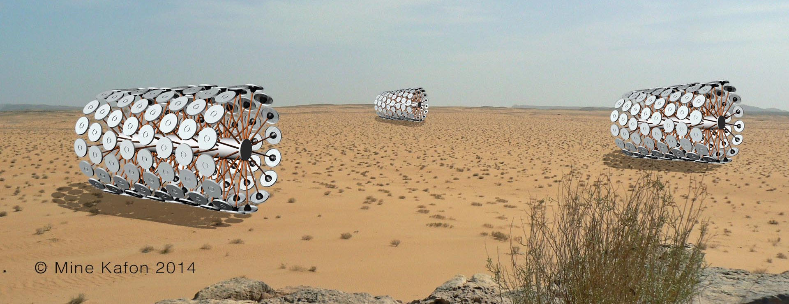

Opening Times for OPEN WORLD
OPEN WORLD opens on 20 February 2015 and continues until the end of Dutch Technology Week on June 6th. Kazerne is open from 11:00 till midnight. There is no charge for visiting the exhibition.

Mine Kafon is part of the second exhibition within the OPEN theme in Kazerne, a venue that has quickly established itself as the new international podium for the creative industries. It is located in former military barracks in the centre of Eindhoven, Holland’s smart tech and design capital. In the exhibition space there’s also a bar and a restaurant, so the worlds of technique, design and art can literally come together with fine dining and drinks.

OPEN WORLD celebrates the work of contemporary artists and designers - they are the inspiration for the development of new materials and aesthetic forms, as well as providing new insights. It shows how the open mind and attitude of the various creative industries can identify important societal issues. Kazerne is the vivid venue to see the inspiring solutions they’ve come up with – both high and low tech.”

Besides the scoop from Massoud Hassani, the exhibition features work of designers and artists including Steven Banken, Joost van Bleiswijk, Raw Color, Ritchie van Daal, Kiki van Eijk, Studio Drift, Paul Heijnen, Jeffrey Heiligers, New Window x David Derksen, New Window x Ola Lanko, The OceanCleanup, Laura Lynn Jansen & Thomas Vailly, David Marin for Baltan Laboratories, Arnout Meijer, Nightshop for DHPH, and Os and Oos.
For more information, check: www.kazerne.com

Note for editors. Not for publication.

You are most welcome to visit the OPEN WORLD exhibition.
Street Address: Kazerne, Paradijslaan 2-8, 5611 KN Eindhoven, The Netherlands. We’re close to public transport (Eindhoven airport, bus and train station). There are several city parking garages close by. Here’s the route description.

For more information or for interview requests, please contact Annemoon Geurts: Tel: +31 6 22529413 or email: annemoon@kazerne.com. Please tell her if you’re working to a specific deadline.

Free of rights images are available via
http://kazerne.com/en/more/press/press-kit

