MEDIA release
July 29th, 2015

Lidewij Edelkoort is the first guest curator to be featured at Kazerne Eindhoven
This will be the first time The Edelkoort Design Collection is exhibited in the Netherlands

OPEN ENDED: Dutch AND AUTONOMOUS DESIGN

FROM 1995 – 2015
June 20th to September 28th 2015 (under embargo until September: due to great success the exhibition will be extended until Januari 2016, including Dutch Design Week 2015 (17-25 Oct))

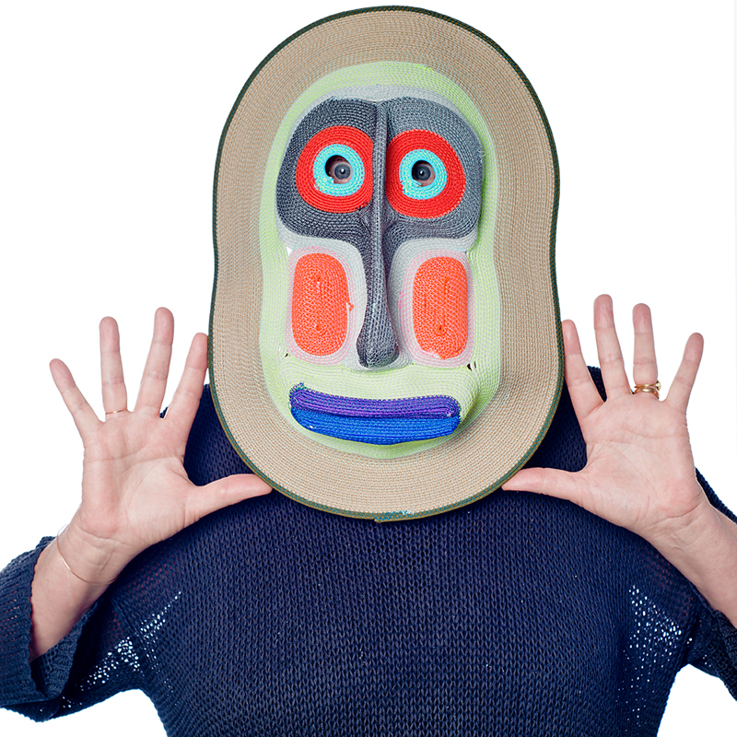
For the first time in the Netherlands: the iconic Edelkoort Design Collection. The respected trend forecaster Lidewij Edelkoort presents a part of her personal art and design collection at Kazerne, the creative cluster in Eindhoven. With this exhibition, together with a series of lectures, debates and informal meetings, Kazerne explores the vision, influence and significance of Edelkoort in the design world. With works by Alvar Aalto redesigned by Ilse Crawford, Maarten Baas, Humberto & Fernando Campana, Piet Hein Eek, Kiki van Eijk, Jamie Hayon, Richard Hutten, Rei Kawakubo, Bertjan Pot, Studio Job, Tjep, Marcel Wanders and Oscar Zieta, among others, OPEN ENDED offers an overview of Dutch and international autonomous design at the turn of the century; a period during which Dutch design gained international recognition.

Lidewij Edelkoort with a mask by Bertjan Pot - photo: Camiel Donders, commissioned by TextielMuseum, 2013

The creative cluster Kazerne explores the vision, influence and significance of Lidewij Edelkoort
It is generally agreed upon that Lidewij Edelkoort has had an enormous influence on the development of design, both in the Netherlands and further afield. Also in the promotion of the Design Academy, of Eindhoven as a City of Design and of the Brainport region, her significance has been incalculable. And thanks to her unfailingly sharp eye for talent and her unerring sense of the developments about to overtake us, she continues to be of immense support to many individual artists, designers and entrepreneurs, and indirectly through them to society as a whole. But what of this significance? What has this one personality meant to an entire generation? The new podium for the creative industries, Kazerne in Eindhoven, explores the vision influence and significance of Edelkoort, with an inspiring exhibition, a series of lectures, debates and informal meetings.

An overview of Dutch and autonomous design at the turn of the century
A recent presentation of The Edelkoort Design Collection in Paris attracted a large number of visitors. This first showing of the collection in Eindhoven includes many new acquisitions and connections with the local design community.

Edelkoort describes the exhibit: ‘Composed of work from the most important designers working around the turn of the century, many of them with links to the Netherlands, the collection shows how attitudes to design have changed and are coming of age. The evolution of autonomous design is a focal point. The works of a number of local heroes is on display, alongside world-renowned talents, celebrating the creative spirit of the city of Eindhoven, and representing a feather in the cap of education.’

‘I am honoured to be the first guest curator to present an exhibition at Kazerne; I find it particularly satisfying to be able to show my own art and design collection here in Eindhoven, where I spent seventeen years working in education and presenting exhibitions. This exhibition demonstrates what has been achieved here in Eindhoven, and how these achievements have then gone on to influence the world. The collection also shows really well what great creative spirits are capable of, and I hope it will inspire new generations of creatives to dare to go further, to seek genuine renewal and to make the necessary leaps forward.’

Dutch design from the perspective of autonomous design
Edelkoort was one of the first to recognise the phenomenon of autonomous design in the mid-1990s. She then picked up the trend, drew attention to it and made sure that it became widely recognised. She also made the artists she stimulated and inspired aware of the power of this form of design, challenging them, in particular, to incorporate more of their own individual personalities into their design work: a set of individual characteristics which would speak through their work, express their feelings, and enabling public and users alike to value or understand their work without the need to be experts or connoisseurs, simply because they could feel it. Examples of this are the ‘Smoke Collection’ from Maarten Baas, ‘Big White Pot and Red White Vase’ from Hella Jongerius and the ‘Knotted Chair’ by Marcel Wanders. It was Lidewij Edelkoort who took Dutch design as autonomous art and helped transform it into an internationally recognised concept. And throughout this period of time she assembled her own collection of design, art and objects, creating a portrait and timeline of design at the turn of the century. An open-ended collection.

‘One of the world’s 25 most influential people’
As an intuitive thinker and world traveller, Lidewij Edelkoort shares her vision of socio-cultural trends with strategists, designers and marketers in widely diverse fields: she advises businesses such as Philips, Nissan, Esprit, Siemens and L’Oréal, as well as the Dutch government and ministries. Her perspective is often felt; for instance, she recently shook up the fashion world with her Anti-Fashion manifesto: declaring that fashion is dead through ten reasons why the fashion system is obsolete.

Trend forecaster, curator, publisher and educational specialist, Edelkoort studied fashion and design at the Arnhem College of Art. In 1986, she founded the collective Trend Union and her own Studio Edelkoort in Paris. From 1999 to 2008, she was chairwoman of the Design Academy Eindhoven. This year, she is starting a new position as Dean of Hybrid Design Studies at the prestigious Parsons The New School in both New York and Paris.

In 2003, TIME Magazine described Lidewij Edelkoort as ‘one of the world’s 25 most influential people in fashion'. In 2008, she was made a Chevalier des Arts et des Lettres by the French Ministry of Culture, a Knight of the Order of Oranje Nassau in the Netherlands, and in 2011 she was awarded the prestigious Dutch Prince Bernard Prize for Culture. These are just a few examples of her innumerable honours and achievements.
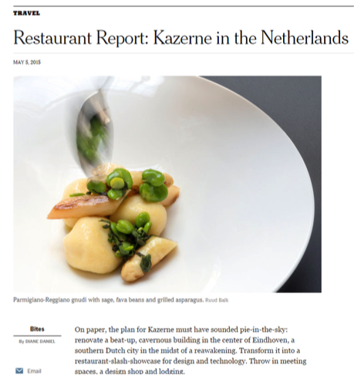
International Creative Cluster Kazerne
OPEN ENDED – Lidewij Edelkoort is the third and final exhibition with the theme OPEN at Kazerne, a cultural space that has firmly established itself as a new international podium for the creative industries in recent months. Kazerne occupies a former military-police barracks (“Kazerne” in Dutch) in the centre of the design and technology city of Eindhoven; an inspirational location, already gaining rave reviews by many, including The New York Times. In the exhibition spaces, which include a bar and restaurant, the worlds of technology, design and art come together with fine cuisine. Kazerne taps into the potential for these creative industries to be the driving force and inspiration of a more beautiful, humane and sustainable way of living. Seen not from a distance, like in a museum, but in a vibrant environment where food and drinks can be enjoyed, in the surroundings of the exhibition, until late in the evening it offers a completely different experience.

OPEN ENDED – exhibition – book – lectures – debates – informal meetings
In connection with the exhibition at Kazerne, a book – OPEN ENDED – is to be published, with views and essays about design by Lidewij Edelkoort. Literally an open-ended book, since like the collection, the book is not complete; in the years to come, further chapters will be added. Kazerne is also organising a series of lectures, debates and informal meetings in which diverse networks will reflect on the vision, influence and significance of Lidewij Edelkoort and upon the added value of the creative industries in general. During these meetings, designers, their clients and producers who commission them will dine together to get to know each other and exchange ideas. More details coming soon at www.kazerne.com.

The OPEN ENDED exhibition is on show from June 20th to September 28th 2015
(under embargo until September: due to great success the exhibition will be extended until December 2015, including Dutch Design Week (17-25 Oct))
Kazerne is open daily from 11:00 to midnight. Visitors can also enjoy coffee, lunch, drinks and dinner. Entry to the exhibition and Wi-Fi are free of charge.

For more information, visit www.kazerne.com

For more information or to request an interview please contact Annemoon Geurts on 06 22529413, or
e-mail annemoon@kazerne.com Please let her know if you are working to a deadline.

Free-of-copyright, high-resolution images are available upon request. See also: http://www.kazerne.com/en/more/press/press-kit

