MEDIA release
02 2016

Jeroen Junte second guest curator at the Kazerne Eindhoven creative cluster
Junte compiles first comprehensive overview of new generation of designers

EXPO NEXT UP: Dutch Design BY A NEW, ENGAGED, post-crisis GENERATION

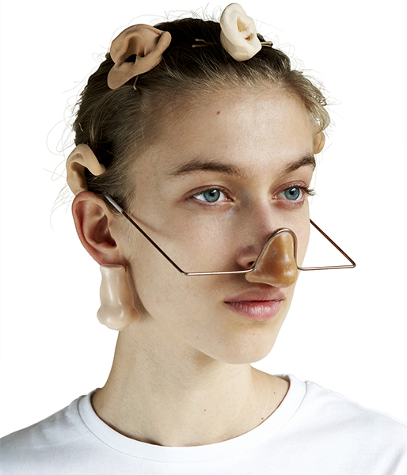
From Sunday 21 February, the Kazerne creative cluster will host a retrospective exhibition entitled NEXT UP – Jeroen Junte: Dutch design by a new, engaged, post-crisis generation. In this exhibition, guest curator Jeroen Junte presents an overview of the latest generation of Dutch designers. Featuring almost 200 works by over 60 designers – including Marjan van Aubel, Teresa van Dongen, Dave Hakkens, Dirk van der Kooij, Arnout Meijer, Aliki van der Kruijs, Lex Pott, Thomas Vailly & Laura Lynn Jansen, Sander Wassink and Jolan van der Wiel – the exhibition will be the first overview of the generation that came of age during the credit crunch. Junte: “The engagement and open-mindedness of these young designers is remarkable. They think in terms of opportunities and solutions rather than problems and obstacles.”

Image Alix Gallet: Tricking biometrics by Femke Rijerman

First comprehensive overview of new generation designers
NEXT UP is the world’s first exhibition presenting the entire spectrum of post-crisis design. This new generation of designers elaborates on the inquisitive, critical attitude of Dutch design, while at the same time striving to contribute positively to social issues. These engaged designers don’t just ask questions, they also look for answers. They deploy instinct and intuition just as much as conceptual exploration and a critical attitude. They are both thinkers and doers.

Engaged and resolute: pragmatic idealism
Guest curator Jeroen Junte on NEXT UP: “Yes, of course, contemporary young designers came of age during the crisis. Raw materials are running out, energy is becoming scarce and globalization is making new, small-scale production essential. That requires engagement and resoluteness. And, no, they are not disheartened. They are enterprising and have no trouble switching between industrial and independent production. They are pragmatists and are oblivious to existing boundaries that compartmentalize art, design, science and even the service industries. They plot their own course, and their course is in ascendance. They are next up!”

Nine themes create a complete overview of the contemporary field of design
NEXT UP is divided into nine crucial themes that characterise not only the NEXT UP generation but the entire contemporary field of design: functional concepts (storytelling), 3D printing and open design (Do It Ourselves), pure materials and shapes (Making More From Less), biodesign and sustainability (Beyond Green), advancing digitization (Dematerialize), making technology accessible (Slow Tech), social interaction as a product (At Your Service), innovations in recycling (Upcycling Recycling) and small-scale, process-driven production (Perfect Imperfection). For a full list of exhibiting designers, visit: www.kazerne.com.

Design critic Jeroen Junte
Jeroen Junte is a freelance design journalist, curator, moderator and event organiser. He is a regular contributor to the Dutch daily De Volkskrant, the international magazine Frame and monthlies such as Elle Decor and Architectuur NL. In addition, he has written books about design such as the Design Nederland Must See travel guide, the compendium Think Dutch. Conceptual Architecture and Design in the Netherlands and the bilingual edition Hands on. Dutch design in de 21ste eeuw / in the 21st century. In 2014 he curated the Slow Tech – Design between Craft and Industry exhibition at the WOW cultural platform in Amsterdam. Since 2012 Junte has been organizing the live magazine Design Matters every two months at Pakhuis de Zwijger in Amsterdam, featuring interviews, presentations, debates, spoken columns and lectures by a variety of guests.

The Kazerne creative cluster
‘NEXT UP – Jeroen Junte’ is the first exhibition in the Next series at cultural hotspot Kazerne. Receiving more than 100,000 visitors in its first year, this new international arena for the creative industries has positioned itself firmly in the international field of design. Kazerne is housed in a former military police barracks and an industrial warehouse in downtown Eindhoven, the city of design and technology. In the gallery areas, which include a bar and restaurant, the experience of technology, design and art literally merges with good food and drink. Kazerne emphasizes the power of the creative industries to drive and inspire the development of a more beautiful, humane and sustainable living environment. Not from a distance, like in a museum, but rather in a live situation where you can eat and drink until late at night, surrounded by the exhibition.

The NEXT UP exhibition is on show from 20 February until 26 September 2016
Kazerne is open daily from 11 am until midnight, including for coffee, lunch, drinks and dinner. Entrance to the exhibition and wifi are free of charge.

For more information, visit www.kazerne.com

For more information or to request an interview please contact Jeroen Junte on +316 26504771 or Annemoon Geurts on +316 22529413, or e-mail annemoon@kazerne.com Please let us know if you are working to a deadline.

Free-of-copyright, high-resolution images are available upon request. See also: http://www.kazerne.com/en/more/press/press-kit. As from 10 February new images will be uploaded regularly.

Kazerne Expo NEXT UP - Jeroen Junte
FEATURING Rogier Arents, Marjan van Aubel, Steven Banken, Merel Bekking, Daniel de Bruin, Collectie Veenhuizen, Lilian van Daal, Daphna Laurens, David Derksen, Teresa van Dongen, Govert Flint, Allix Gallet, Gionata Gatto & Mike Thompson, Dave Hakkens, Handmade Industrials, Paul Heijnen, Nienke Hoogvliet, Jesse Howard, In Limbo Embassy, Thomas Vailly & Laura Lynn Jansen, Jesse Kirschner, Nynke Koster, Dirk van der Kooij, Aliki van der Kruijs, Lemz, Sam Linders, Jelle Mastenbroek, Roos Meerman, Arnout Meijer, Studio Minale Maeda, Isaac Monté, Bastiaan de Nennie, Dirk Osinga & Lotte de Raadt, Pink Pony Express, Nienke van de Pol, Simone Post, Lex Pott, Studio rENs, Chloé Rutzerveld, Sheltersuit, Stone Cycling, StudioStudio, Emilie van Spronsen, Leonie Tenthof van Noorden, The Incredible Machine, Unaware Objects, Sander Wassink, Jólan van der Wiel.

