KAZERNE MediA RELEASE
June 21, 2017

KAZERNE EXPO NEW ICONS FEATURING Atelier NL (t.e.), Maarten Baas (Lensvelt), Joost van Bleiswijk, David Derksen, Studio Drift, Jella Lena van Eck, Piet Hein Eek (Social Label), Jalila Essaïdi, Dave Hakkens, Arne Hendriks, Chris Kabel & St. Joris (Label/Breed), Jelle Mastenbroek & OWOW, Christien Meindertsma & Enkev (Label/Breed), Bertjan Pot (Weltevree), Studio Wieki Somers (t.e.), VanTot (Envisions), Emma Verhoeven, Edwin Vollebergh (Social Label), Marcel Wanders (Moooi)

Celebrating 100 years of De Stijl

NEW ICONS - Rietveld Now
What if Rietveld, Mondriaan and Van Doesburg lived in the here and now?

EINDHOVEN, the Netherlands -- Visitors to Eindhoven will be have the opportunity to enjoy the latest work of (up-and-coming) leading designers like Maarten Baas, Jelle Mastenbroek and Jella Lena van Eck. Their concepts and installations explore themes of today including fake news, big data and privacy. In the indefatigable spirit of immense inventiveness, whose legacy traces back to De Stijl, creative hub Kazerne links up with this year’s theme of Mondriaan to Dutch Design.

In 2017 The Netherlands is celebrating 100 years of art movement De Stijl. From 24 juni to 9 October, Kazerne in Eindhoven will be holding a large exhibition, with the goal of finding out who are today’s great innovators in the world of design: what if Rietveld, Mondriaan and Van Doesburg lived in the here and now? Kazerne is an internationally recognized combination design gallery, restaurant, and lounge in Eindhoven, the hotbed for Dutch designers.

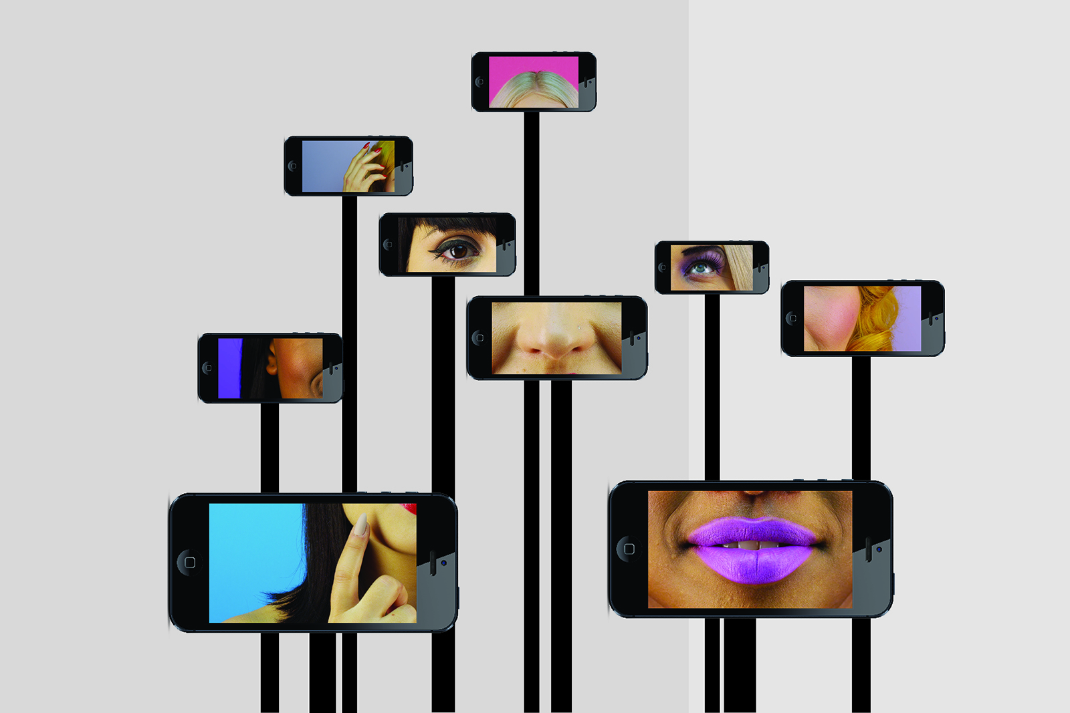
Adore me@... by Jella Lena van Eck

NEW ICONS – Rietveld Now – shows recent concepts, objects and installations by leading designers, both established and up-and-coming. The interest of the podium for design surpasses the aesthetic qualities of De Stijl, the characteristic combination of straight lines and primary colours. The shown work connects to the incentives of the avant-garde from that time: the blending between form and function and especially the search for a universal visual language that does justice to the new society. The questions being asked include: if Rietveld were alive today, what would he be making? Which work has the potential to become as iconic as Rietveld’s Red and Blue Chair? From which designer can we expect a legacy that will survive for generations to come? The no-nonsense designs by Piet Hein Eek, the much-praised oeuvre by Maarten Baas, or the conceptual projects by Arne Hendriks? Together with designers and the public, Kazerne attempts to grasp the zeitgeist and predict which designers and labels will survive the ravages of time. Visit www.kazerne.com for the programme and all the latest updates.

Maarten Baas, for instance, presents his latest work May I have your attention please? The installation (Milano Design Award 2017 Best Concept winner) consists of a thicket of megaphones on stands, emitting unintelligible messages. Baas: “If we’re not careful, the cacophony of voices, opinions, news reports and trivia come to form a patchwork in which fact and fiction become increasingly more difficult to differentiate from one another.” Maarten Baas, renowned worldwide as a leading designer, became the youngest Designer of the Year ever in 2007, Dutch Design Week ambassador in 2016 and is currently presenting a large solo exhibition in the Groninger Museum.

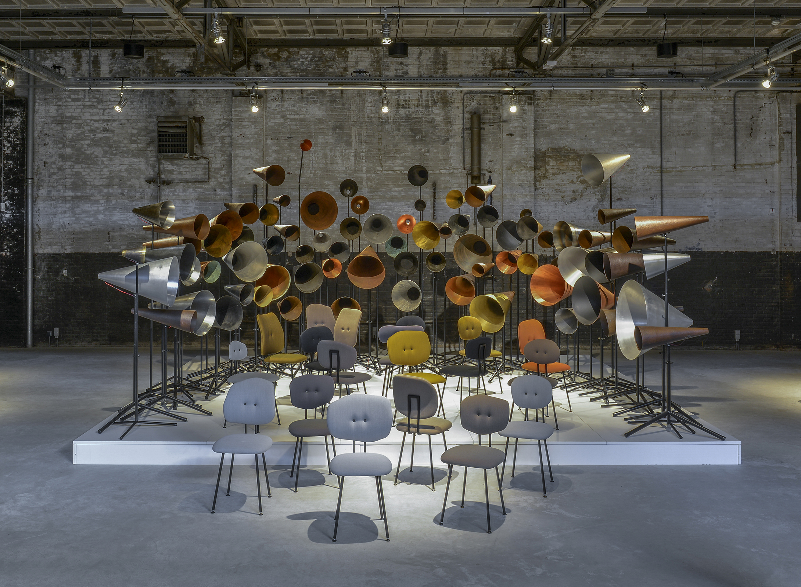
May I have your attention please? by Maarten Baas, Chairs101 by Maarten Baas for Lensvelt

Jelle Mastenbroek continues work on his Data Orchestra for which he won the Milano Design Award in 2016. “In the world of business your personal data is a highly valuable commodity. Data Orchestra turns the tables, rewarding the owner of the data with a personal concert based on their data.”

Young talent Jella Lena van Eck presents her graduation project (Design Academy, January 2017) Adore me@...: a video installation with one female face distributed over multiple cell phones: the oracle of Instagram. She tells you succinctly, manipulatively and with brutal honesty what to change about your original self in order to be Insta-famous and worshipped online.

NEW ICONS comes in the run-up to the World Design Event of the Dutch Design Foundation. With recent works by leading designers it complements the project Van Abbe and De Stijl in the Van Abbe Museum. It is also part of the City Walk Roundabout Design and Designer for a Day by EHV247.

About Kazerne
Kazerne, featured in the New York Times, shows work by dozens of prominent design talents throughout its 2,000 square meters of space and has distinguished itself as the Eindhoven hot spot where art and technology meet – along with good food, drinks and friends. They serve high quality vegetable-oriented food with an Italian twist, including vegetarian dishes. The menu changes regularly, to take advantage of seasonal ingredients.

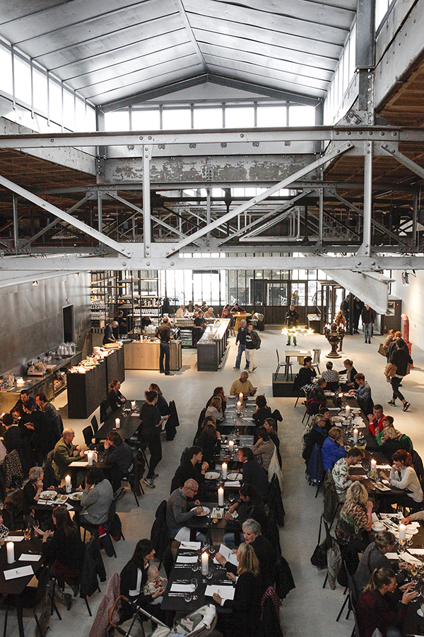
The young creative hub is housed in a former military police barracks (Kazerne means ‘barracks’ in Dutch), and was renovated to highlight its industrial beauty. The boardrooms can be reserved for both business and private events – from high-level dinners to large corporate functions. In October 2018 the complete heritage will be renovated. By then, the boutique hotel will open up, where you will be able to sleep within the exhibition.

“Kazerne pays particular attention to the power of the creative industry as the driving force and source of inspiration for a more beautiful, more humane and more sustainable living environment,” says co-founder and creative director Annemoon Geurts. “In contrast to regular museums, we have opted for a lively environment where you can eat and drink until late at night while being surrounded by the exhibition. This allows you to experience the artworks intimately, in an informal relaxed setting.”

Kazerne is located at Paradijslaan 8, downtown Eindhoven and is open daily from 12:00 to midnight for coffee, lunch, drinks and dinner. Guided tours on demand. Visiting the exhibition is free of charge.

For more information or interview requests, contact Annemoon Geurts via +31 6 22529413 or annemoon@kazerne.com.

Free of rights high-res images are available on request and via
http://www.kazerne.com/en/more/press/press-kit
https://www.dropbox.com/sh/qrm61x7rdldobs1/AAAuA4rZusgQ5uRY0E4QEWXYa?dl=0

