KAZERNE @ DDW MediA RELEASE
31 AUGUST 2016

Can we talk about beauty for a moment?
May we cherish beauty as the ultimate free haven?

ESCAPE – embracing the freedom of beauty
Journey into the beauty of intriguing (light) art and design

Forget for a moment the whim of the day. Allow yourself to be swept along by the intruiging beauty of, for example, the kinetic installation In 20 steps by Studio Drift; a tribute to the human desire to be able to fly. Or by the installation Lightfall by Paul Thursfield and Simon Rycroft for Philips and the innovative research into the colours of Rembrandt by Maarten Kolk and Guus Kusters. In the exposition ESCAPE in Kazerne in Eindhoven, you’re embraced by the free haven art has to offer. A free haven void of judgement, void of dogmas and void of fear. It’s time to reflect and get inspired. As of the 7th of October, and during the Dutch Design Week and Light Art Festival Glow.

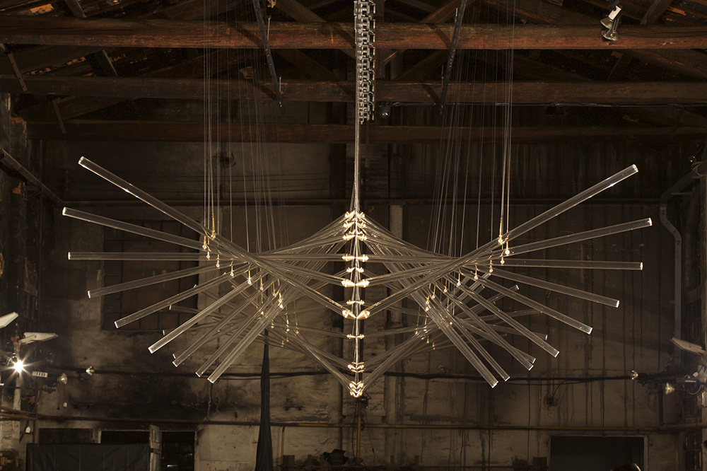
https://vimeo.com/128608936
An impression of the intense beauty of In 20 Steps by Studio Drift

During your ESCAPE you’ll experience intriguing (light) art and design. The contemporary pieces in Kazerne’s exhibition have a great and sometimes even lyrical expressiveness that will temporarily entrance you and make you forget about the whim of the day.

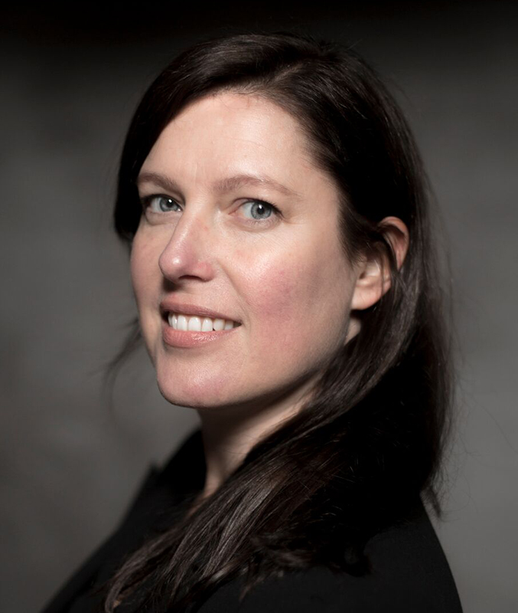
Creative director Annemoon Geurts: “The desire to escape reality is universal, but at the same time very topical. We live in a world that’s becoming more and more complicated. We’re constantly bombarded with headlines full of contrasting emotions. To be able to make sense and grasp the meaning of it all, we require reflective moments, moments in which we can escape reality."

"Now we want to consciously answer this desire to escape by creating a free haven of beauty. A place where we offer room to actual freedom. Without judgement, without dogmas and without fear. A place where you let the intriguing beauty of contemporary art and design, as well as new materials and techniques, embrace you. And where you let yourself be inspired by the hunt for new persuasions and answers to complex, contemporary topics."

Allow yourself to be swept along by the tranquil beauty of, for example, the monumental, kinetic installation In 20 steps by Studio Drift; a tribute to the human desire to be able to fly, even in the face of adversity. Or by the installation Lightfall, with responsive light and soundscapes by Paul Thursfield and Simon Rycroft for Philips.

Other names we can currently list are: Maarten Kolk and Guus Kusters for the Rembrandtlab, Rick Tegelaar and Anton Hendrik Denys. For an up-to-date overview, check out www.kazerne.com.

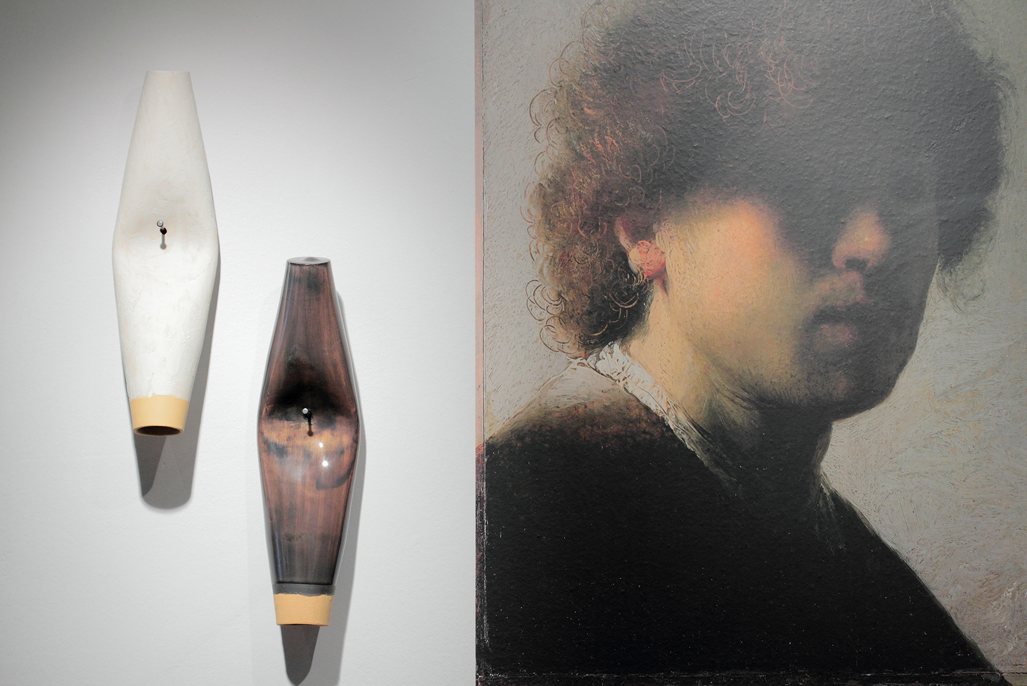
Maarten Kolk en Guus Kusters constructing colours for RembrandtLAB

Reflection and inspiration allow you to let go of dogmas and embrace freedom. The freedom that’s required to innovate. And this also applies to the making of, the theme of the Dutch Design Week 2016 (DDW). Geurts: "We’re investigating how experiencing beauty offers a free haven to create relevant designs. Where and when does an escape come into being? On top of this, we, as participants, have been organising this event for ten years, now. In 2006, the first edition of Kazerne’s predecessor Eat Drink Design; a 9-day pop-up restaurant and exhibition, was held. Nowadays we’re open to the public every single day of the year.
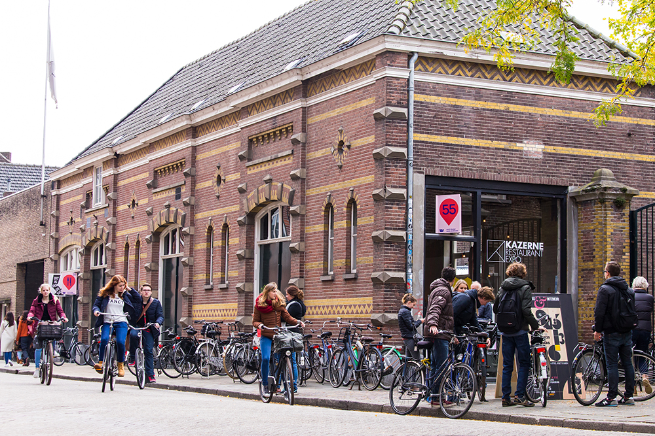
SELECTED PARTICIPANTS DDW 2016
During DDW 2016, the Kazerne exhibition will include even more contemporary art and design by the addition of works by Maarten Baas, Marc Mulders, Jan Koen Lomans, Crafts Council and the nominees for the New Material Award 2016. With 2000 square metres of works by over 80 prominent design talents, the Kazerne is once again THE hot spot where art and technology comes together with good food and drinks.

CREATIVE CLUSTER KAZERNE
Kazerne is the international platform for the creative industry in the heart of design and technology city Eindhoven. With over 100 thousand visitors in the first year alone, the creative hub instantly positioned itself firmly in the international world of design.

Kazerne is housed in the old military police barracks (Kazerne in Dutch) and an industrial warehouse. In the exposition spaces, including a bar and restaurant, the worlds of technology, design and art literally come together with good food and drinks.

Geurts: “On top of this, Kazerne pays particular attention to the power of the creative industry as the driving force and source of inspiration for a more beautiful, more humane and more sustainable living environment. In contrast to regular museums, we have opted for a lively environment where you can eat and drink until late at night while being surrounded by the exhibition. This allows you to experience the artworks up close.”

The inspirational location opened its doors in October 2014 and has already been given raving reviews by the New York Times, for example.

DUTCH DESIGN WEEK AND LIGHT ART FESTIVAL GLOW
Kazerne’s exhibition ESCAPE is on show from October 7, 2016 up to and including February 2017, and includes the Dutch Design Week (DDW, from 22 up to and including 30 October) and the light art festival Glow (12 up to and including 19 November).

De Kazerne is located at Paradijslaan 8 downtown Eindhoven and is opened daily from 11:00 until midnight for coffee, lunch, drinks and dinner.

For more information or interview requests, you can contact Annemoon Geurts via 06 22529413 or annemoon@kazerne.com.
Please let her know if you are working on a deadline.

Free of rights high res images are available on request. See also http://www.kazerne.com/en/more/press/press-kit and
https://www.dropbox.com/sh/gg1rs379hygtggv/AAC4n-DQoZWVvtiLBBTLChaia?dl=0

(Regularly updated, see also www.kazerne.com)

KAZERNE EXPO ESCAPE EXHIBITANTS | 7 OKT 2016 - 24 FEB 2017

Anton Hendrik Denys
Studio Drift
Studio Maarten Kolk & Guus Kusters for Rembrantlab
Simon Rycroft & Paul Thursfield for Philips Lighting
Rick Tegelaar
Carina Wagenaar

SELECTED PARTICIPANTS | DDW 2016

Maarten Baas
Maarten Baptist
Job van den Berg
Crafts Council (Liselore Frowijn, Maaike Gottschal, Aliki van der Kruijs en Adrianus Kundert)
Functionals
Kazerne Young (Axel Coumans , Tijnke van Gelder Léa Mazy, Sebas Reneman, Moreno Schweikle)
Bernhard Lenger
Lucas&Lucas
Jan Koen Lomans en Marc Mulders
New Material Award 2016 (Maarten baas, Buro Belén, Rudolf Romero Borgart, Roel Deden, Eric Geboers, Olivier van Herpt, Studio Dirk van der Kooij, Adrianus Kundert, Rosanne van der Meer, Christien Meindertsma, Maurizio Montalti, Floor Nagler + Didi Aaslund, Bastiaan de Nennie, Antoine Peters, Simone Post, rENs, Diana Scherer, bureau SLA / Overtreders W)
Love Ohlin
Studio Thier&vanDaalen

