Media RELEASE
15 October 2015

Open Ended by Lidewij Edelkoort prolonged until January 2016

Kazerne during DDW: more than 2.000 m2 design, more than 100 designers

This Saturday the Dutch Design Week (DDW) kicks off. With an impressive line-up, Kazerne certainly is one of the DDW hot spots: the expo Open Ended – Lidewij Edelkoort is prolonged and complemented with a special by Brynjar Sigurdarson. Around the courtyard, the work of both starting as well as established designers is presented, with among others: Magazine Eigen Huis & Interieur with the Top 10 of Dutch Designers in a presentation drawn by Piet Paris, SLEM with wearable 3D printed shoes of the 12 best Dutch shoe designers, Maarten Baas for SDK-Vastgoed and up to date work of Pieke Bergmans, David Derksen, Daphna Laurens for Glasmuseum Leerdam, Christien Meindertsma for t.e., Lucas & Lucas, Maaike Roozenburg with Boymans van Beuningen, Morgan Ruben and many others.

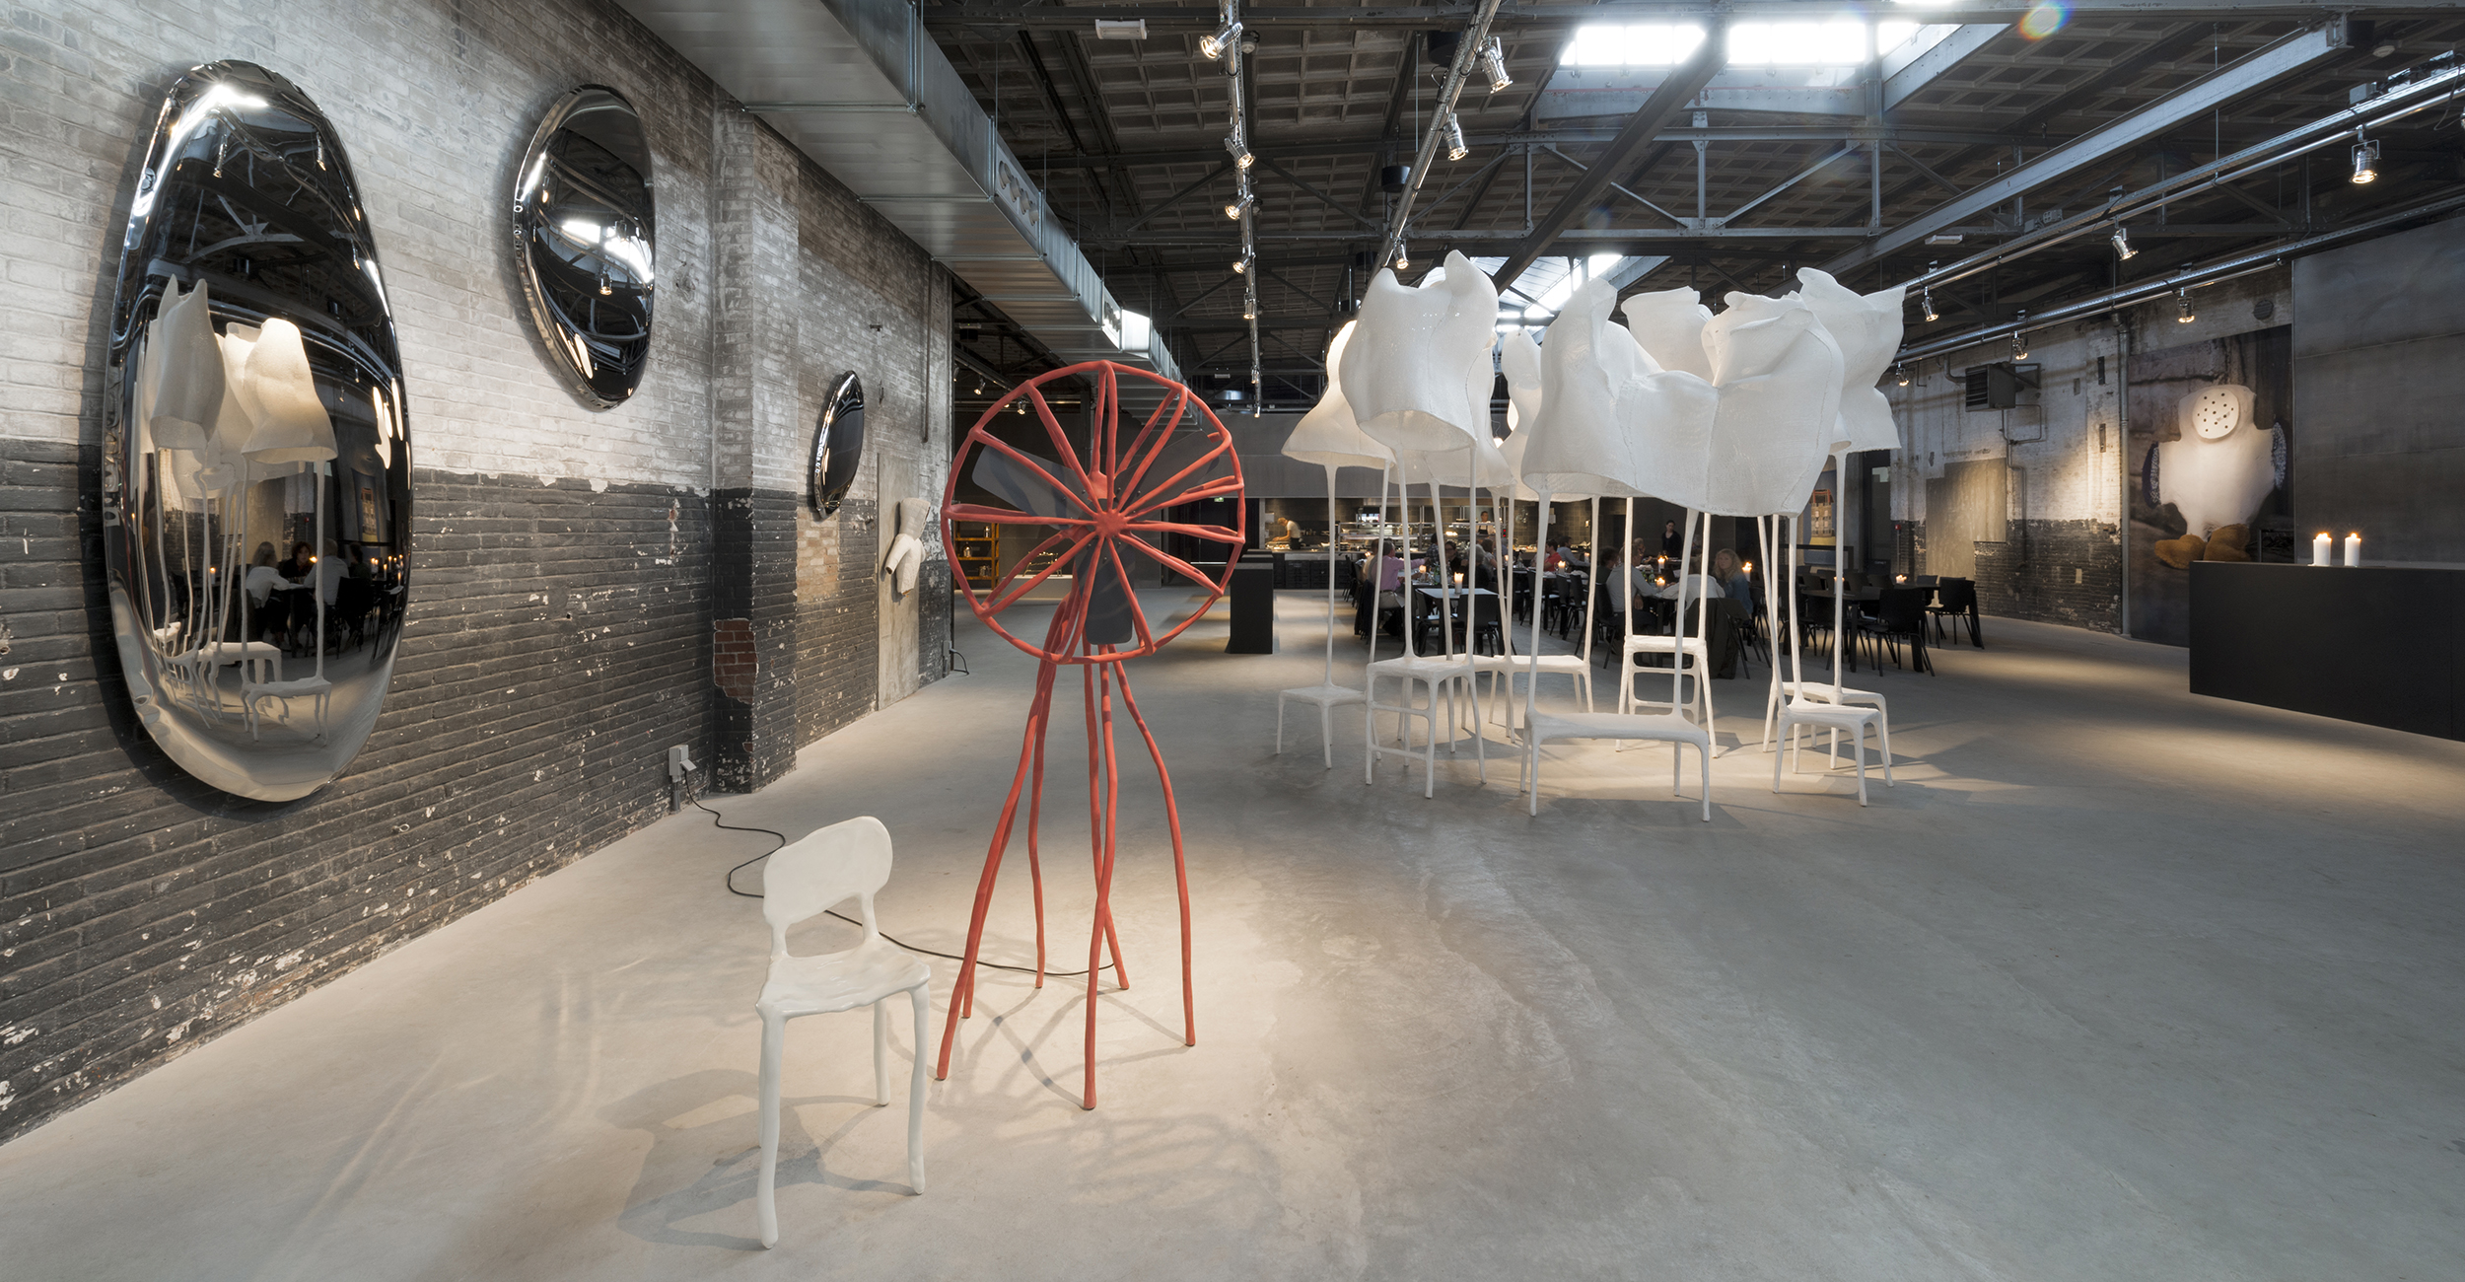

Open Ended by Lidewij Edelkoort in Kazerne. Photo Ruud Balk

Open Ended – Lidewij Edelkoort
During DDW the expo Open Ended by Lidewij Edelkoort, which is prolonged due to success until January 2016, is on show. The world renowned trend forecaster and former head of the Design Academy Eindhoven presents a part of her personal collection. An inspiring overview of dutch and autonomous design from 1990 till now. “Composed of work from the most important designers working around the turn of the century, many of them with links to the Netherlands, the collection shows how attitudes to design have changed and are coming of age. The evolution of autonomous design is a focal point. The works of a number of local heroes is on display, alongside world renowned talents, celebrating the creative spirit of the city of Eindhoven, and representing a feather in the cap of education.” During DDW, a special of Brynjar Sigurdarson is added. Here, the story of Borgþór Sveinsson is told, who returns every winter to his isolated cabin on the countryside of Iceland to look for the ‘Bullfish’.

Kazerne Featuring during Dutch Design Week
During DDW the monumental buildings around the courtyard of de Kazerne are filled with up to date design. After DDW, this part of the heritage will be completely renovated. According to planning, a boutique hotel with 8 guesthouses and a few extra meeting rooms will open up in October 2016.

A few names from the impressive Kazerne featuring line-up: Eigen Huis & Interieur presents the annual Top 10 of the EH&I Top 25 Dutch Designers. Illustrator Piet Paris drew the presentation, which exists of mobiles with portraits of the Top 10 of designers. Innovation- and education centre SLEM presents These shoes are made by printing; wearable 3D printed shoes of the 12 best Dutch shoe designers, under which the Bergmans family. Commissioned by SDK-Vastgoed, Maarten Baas collaborated with Van Aken Architecten on De Bakermat; two designs for the Marconi plaza in Eindhoven on which visitors can vote. Maaike Roozenburg shows her smart replicas, a project with museum Boymans van Beuningen. Furthermore, you can admire the work of, among others: BCXSY, Pieke Bergmans, Daphna Laurens for the Glasmuseum Leerdam, David Derksen, Laura Lynn Jansen & Thomas Vailly, Kranen/Gille, Max Lipsey, Lucas & Lucas, Christien Meindertsma for t.e., New Window, Odd Matter, Morgan Ruben, Nienke Sybrandy, Atelier Rick Tegelaar, Studio Thier&vanDaalen and Jeroen Wand and Alex de Witte.

Meeting place Kazerne
Since one year Kazerne is located in an old military barracks in the centre of design and technology city Eindhoven. An inspiring location, already gaining rave reviews by for example the New York Times. In the exhibition space with bar and restaurant, the worlds of technique, design and art literally come together with good food and drinks, all year long. Not from a distance, like in a museum, but in lively surroundings, where you can eat and drink within the exhibition until late in the evening. This offers a different experience, according to the initiators Annemoon Geurts and Koen Rijnbeek (known for the pop up exhibition restaurant Eat Drink Design, a meeting spot for the public and designers during DDW): “We are extremely proud to let the many international guests enjoy good food and drinks between state-of-the-art exhibitions. With a glass of wine in your hand, you really experience the power of the creative industries.”

Kazerne serves fresh, vegetable and Mediterranean oriented food, including a variety of vegetarian dishes. The menu changes regularly to take advantage of seasonal ingredients. Everything is homemade. The meeting rooms can be reserved for festive and business gatherings – from fine dining private dinners to conferences.

During DDW, expo restaurant Kazerne is – just like the rest of the year – open from 11:00 hr. until midnight, also for coffee, lunch, drinks and dinner. Kazerne featuring is during DDW open daily until 20:00 hr., on Wednesday 21 October till 22:00 hr. Entrance and Wi-Fi are free.

For the full program, see also www.kazerne.com

For more information or interview requests, you can contact Annemoon Geurts via 06 22529413 or annemoon@kazerne.com.
Please let her know if you are working on a deadline.

Free of rights high res images are available on request. See also http://www.kazerne.com/en/more/press/press-kit

OPEN ENDED - LIDEWIJ EDELKOORT
Featuring Alvar Aalto & Ilse Crawford for Artek, Anni Albers and Anthony Kleinepier, Rodrigo Almeida, Anton Alvarez, Atelier NL, Tigran Avetisyan, Maarten Baas, Manu Baeyens, Anthon Beeke, Anthon Beeke Collectief, Pieke Bergmans, Bokja, Tord Boontje, Fernando & Humberto Campana also for Edra, Nacho Carbonell, Michel Charlot, Franck Christen, Daniel Dewer & Grègory Giquel, Piet Hein Eek, Catharina van Eetvelde, Kiki van Eijk, Gam Fratesi for Casa Mania, Gabriela Fridriksdottir, Front for Moooi, Jaime Hayon also for Paula C. and for Moooi, Pepe Heykoop, Richard Hutten for Droog, Studio Job also for Lensvelt and for Moooi, Rei Kawakubo for Comme Des Garçons, Imke Klee, Maarten Kolk & Guus Kusters, Eric Ku, Julia Lohmann, Jon Male, Enzo Mari, Marni, Mathieu Meijers, Ulf Mortiz for Sahco, Julian Opie, Francisco Pinto, Bertjan Pot also for Moustache, Fabien Seiz, Inga Sempé for Edra, Brynjar Sigurdarson, Marie Taillefer, Philippe Omas, Frank Tjepkema, Martin Vallin for Cappellini, Marcel Wanders, Bas Warmoeskerken for Droog, Carolina Wilcke, Yohji Yamamoto, Oscar Zieta

CURATORS Lidewij Edelkoort & Philip Fimmano
ASSISTANT Anne Willem Schenk

SPECIAL Brynjar Sigurdarson

EIGEN HUIS & INTERIEUR TOP 10 DUTCH DESIGNERS
EXHIBITION DESIGN Piet Paris

THESE SHOES ARE MADE BY PRINTING
SLEM Projects by Pauline van Dongen and Leonie Tenthof van Noorden, Ineke Otte, Chris van den Elzen, Charles Bergmans, Sjors Bergmans, Pieke Bergmans, Amber Ambrose Aurèle, Yasser Ballemans, Eva Klabalová, Ruben Lekkerkerker

DE BAKERMAT
Maarten Baas and Van Aken Architecten for SDK-Vastgoed

SMART REPLICAS
Maaike Roozenburg with Museum Boijmans Van Beuningen, Technische Universiteit Delft and Digital Agency LikeFriends

KAZERNE LAB
Izabela Boloz & Heijmans, Massoud Hassani & Mark Brand

KAZERNE FEATURING
BCXSY for Calico Wallpaper and Michiel Drijver, Pieke Bergmans, Joost van Bleiswijk, Daphna Laurens for Glasmuseum Leerdam, David Derksen, Kiki van Eijk, Laura Lynn Jansen & Thomas Vailly, Kranen/Gille for Leff, Max Lipsey, Lucas & Lucas, Christien Meindertsma for t.e., New Window x Aliki van der Kruijs, Kok Pistolet & Felix van Dam and Rogier Arents, Odd Matter, Rado, Morgan Ruben, Siba Sahabi, Scenery Label, Geraldine Spilker, Nienke Sybrandy, Atelier Rick Tegelaar, Merel Theloesen, Studio Thier&vanDaalen, Studio Thomas Voorn, Jeroen Wand, Alex de Witte

