MEDIA RELEASE
10 October 2018

^{NEW EXHIBITION AT KAZERNE:}
ONGOING DIALOGUE – NEW DESIGN BY OLD FRIENDS

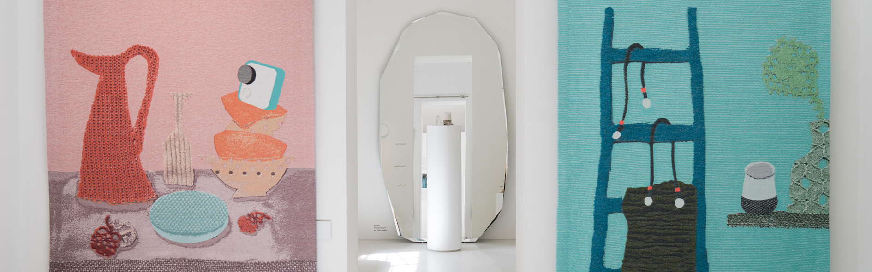
This exhibition celebrates the many designers who contributed to Kazerne becoming a Home of Design. Recent work by over 40 leading and promising designers including Lidewij Edelkoort & Kiki van Eijk for Google, Maarten Baas, Studio Drift and Léa Mazy will be on display until spring 2019.

SOFTWEAR - Lidewij Edelkoort & Kiki van Eijk for Google

EINDHOVEN – The new exhibition ‘ONGOING DIALOGUE – New Design By Old Friends’ is a token of appreciation to all stakeholders who contributed to Kazerne becoming a Home of Design. The exhibition opens the first Saturday of Dutch Design Week 2018 (DDW).
The exhibition is partly situated in the former military barracks in the center of design capital Eindhoven, which have been recently renovated with much respect for its heritage.
In December Kazerne will open as a Home of Design: a unique concept where guests can eat, drink, meet, work and even sleep surrounded by museum quality exhibitions. In the adjacent industrial warehouse, which was renovated and opened in 2014, visitors can discover recent work by old friends - as can be expected from Kazerne with both established names and promising talent. For example, Joost van Bleiswijk presents an outdoor kitchen, Maarten Baas an ode to MB and Léa Mazy her Design Academy graduation project. Both Modular and Ontwerpduo & Cleary Led present lighting innovations, Lucas & Lucas their IKEA hacking project and Studio Drift the enchanting Meadow. Lidewij Edelkoort & Kiki van Eijk will present the Dutch première of SOFTWEAR for Google. With recent work by over 40 leading and promising designers, Kazerne is once again one of the hotspots of DDW to get inspired by the design of tomorrow.

Home Of Design
“To have as many people as possible experience - in a hospitable surrounding - how design adds value to the world we live in; that is the mission of Kazerne,” states founder and Creative Director Annemoon Geurts. “The ongoing dialogue with starting and established designers and their stakeholders such as labels, manufacturers and exhibition spaces, are of major importance. Through their work, experiments and perspectives we show a glimpse of the future.”

Kazerne exists through the ever-growing community of designers and design lovers, who acknowledge the importance of a platform for design in Eindhoven. With the completion of the current renovation by the end of 2018, the creative hub will be expanded with over 1.000 m2 extra exhibition space, including eight hotel rooms (where you can sleep surrounded by recent design), two extra event spaces, a fine dining restaurant, design shop and a members club; a living room for the design community. The initiative, that started in 2006 as the pop-up expo restaurant ‘Eat Drink Design’ and opened the expo restaurant on a daily basis in the industrial warehouse in 2014, will hereby transform into a true ‘Home of Design’.

As a token of appreciation, ONGOING DIALOGUE celebrates the role of the design community in establishing Kazerne, combining recent works by old friends with brand new talent. The exhibition shows various concepts and installations with urgent themes such as impermanence (Studio Drift), imperfection (Léa Mazy) and the role of technology in daily life (Lidewij Edelkoort & Kiki van Eijk for Google).

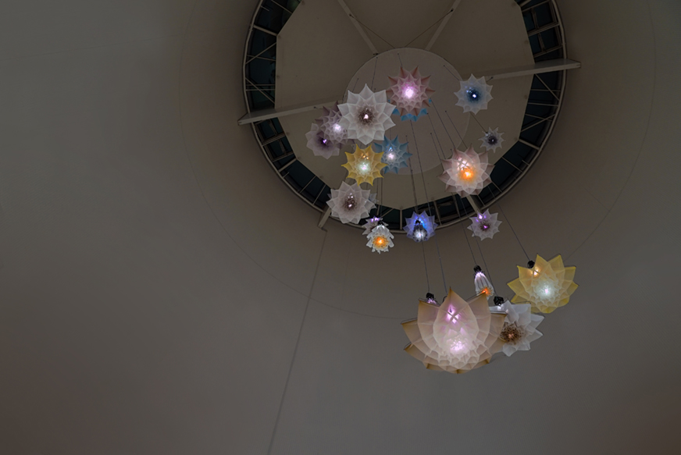
Studio Drift returns with Meadow
Meadow is a kinetic installation consisting of mechanical flowers that open and close in a poetic choreography. The installation recalls a reversed landscape and the transience of the constantly changing seasons. “We have presented work by Lonneke Gordijn and Ralph Nauta since 2007, "says Annemoon Geurts. "Much of the work that was on display in the successful
Studio Drift exhibition CODED NATURE at Stedelijk Museum Amsterdam was shown in our pop-ups and here in Kazerne. We are, and remain, a fan of their enchanting artworks and their ongoing research into the relationship between nature and technology."

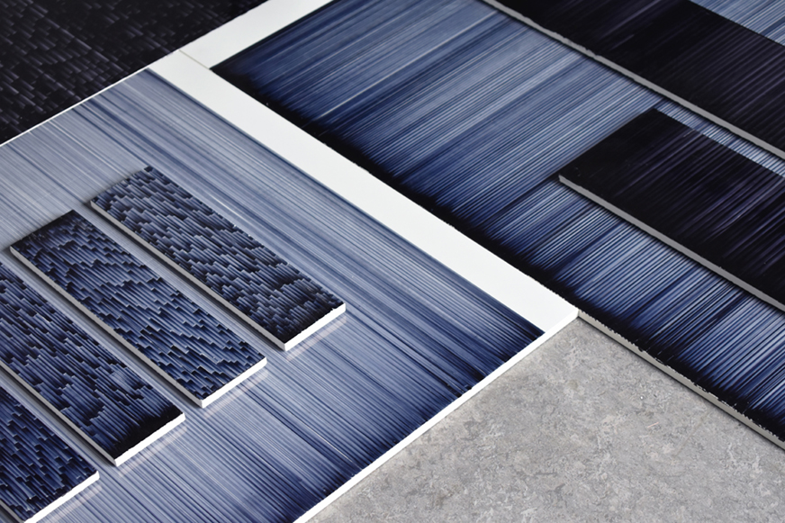
Surprising view on imperfection
The production of fatigue is the graduation project of young talent Léa Mazy (Design Academy, 2018). Her research into the systematic yet unexpected output of a printer running out of ink reveals the aesthetic quality of imperfection. With this, she offers a new perspective on the high expectations of our society regarding efficiency and productivity. Lea is one of the first members of Kazerne Young, a collective of students who organize a theme evening in Kazerne every month.

SOFTWEAR by Lidewij Edelkoort & Kiki van Eijk for Google
Already in 1998, trend forecaster Lidewij Edelkoort foresaw how technology would be blending into our day-to-day life. Now 20 years later she revisits her concept with the presentation of SOFTWEAR, an installation that demonstrates how new hardware products by Google seamlessly integrate into our daily lives, instead of disturbing them. Kiki van Eijk designed a series of tapestries that ‘weave’ into the SOFTWEAR story, starting with collages created with the same textiles that were used by Google in their new products. SOFTWEAR's integration of textiles, tactility and wellness calls for a discussion about the future of technology, big data and its integration in our lives. The installation made its debut at the Salone del Mobile in Milan last April and is now on show in the Netherlands for the first time. Lidewij Edelkoort previously curated the Kazerne exhibition OPEN ENDED. Kiki van Eijk shows her work on a regular basis in Kazerne, ever since the first Eat Drink Design pop-up.

ONGOING DIALOGUE features: Ahrend, Maarten Baas, Contempo Gallery, Daphna Laurens, David Derksen, Studio Drift, Jella Lena van Eck, Lidewij Edelkoort & Kiki van Eijk for Google, Jesper Eriksson, Aleksandra Gaca, Sander Hagelaar, de Intuïtiefabriek, Kazerne Young, Studio Maarten Kolk & Guus Kusters, Lotte van Laatum, Geke Lensink, Lucas & Lucas, Studio Martens & Visser, Jelle Mastenbroek, Léa Mazy, Studio Mieke Meijer, Meyers & Fügmann, Isaac Monté, Mosa, Modular, Not Only White, Studio Isabel Quiroga, Atelier Robotiq x BCXSY, Floris Schoonderbeek, Social Label x Kranen Gille en Dick van Hoff, Atelier Rick Tegelaar, Studio Thier&vanDaalen, Studio Toer, Tools for Progress, VANTOT, Jeroen Wand, Studio Alex de Witte, Zavier Wong.

Kazerne Lab: Joost van Bleiswijk x MCB x Roxal, Kiki van Eijk x EE Exclusives, Studio Maarten Kolk & Guus Kusters x Cor Unum, Ontwerpduo x Cleary Led, Studio Thier&vanDaalen x Bruns.

Dutch Design Week (20 - 28 October 2018)
Kazerne endorses the DDW 2018 theme ‘If not us, then who?' through its mission to continuously highlight the role and value of design. Moreover, Kazerne adds a new exhibition about the ongoing dialogue between design makers, enthusiasts and critics. During DDW, in addition to the new exhibition, visitors will also have the opportunity to take a first look at the ground floor of the renovated heritage.

Eat & Drink
Drop by for a delicious lunch, refreshing drinks or dinner. At Kazerne, you can order espresso and chocolate truffles, bubbles and oysters, a robust pasta or salad, all with accompanying wines.
For just 35 euros, you can enjoy a 3-course menu.

During Dutch Design Week 2018, Kazerne’s exhibition and restaurant are open daily from 11 AM. Closing time of the exhibition is 8 PM, with the exception of the exhibition in the restaurant and the meeting rooms, which close at midnight.

Admission is free of charge with a restaurant reservation, a DDW passe-partout or a press accreditation. Without one of these options, the entrance fee is 2 euros per person. By enjoying a drink or a bite during your visit, you help Kazerne to keep the future admission price low.

Kazerne is found at Paradijslaan 2-8, in the center of Eindhoven, the Netherlands.
www.kazerne.com

About Kazerne
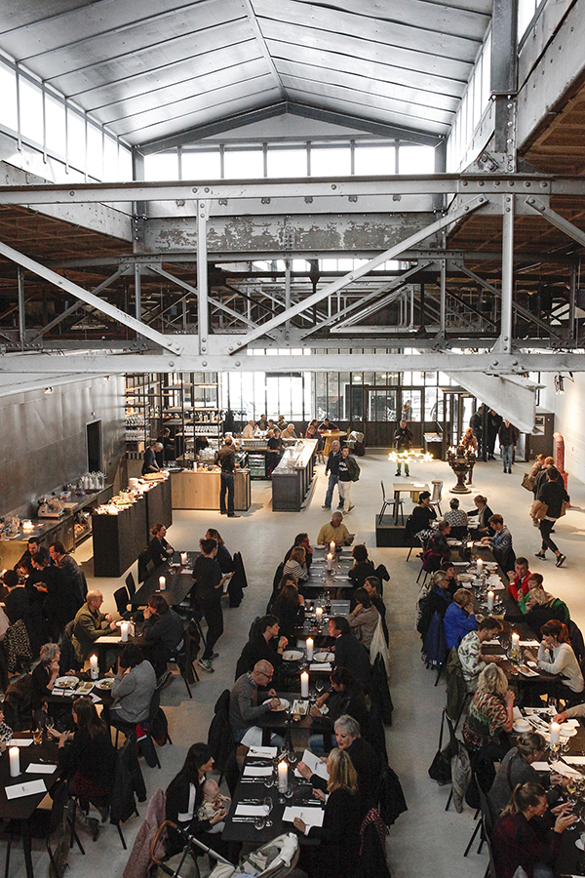
Kazerne, reviewed in the New York Times, shows work by dozens of leading design talents and distinguishes itself as the Eindhoven hotspot where the worlds of design, art and technology meet - best enjoyed with friends, great food and drinks. The kitchen works with seasonal and fresh products and is vegetable-oriented, with an Italian twist. There are always several vegetarian dishes available. The menu changes regularly.

The creative hub, with restaurant, meeting spaces and hotel, is housed in former military barracks and municipal cleaning warehouse, which were renovated with an eye for detail of the original industrial and monumental aesthetic. From the first Eat Drink Design pop-up in 2006, Kazerne is transforming to a unique hospitality concept made possible with the support of a growing community and many partners.

"Kazerne highlights the value of the creative industry as a driving force and source of inspiration for a better, more human and more sustainable society," says co-founder and Creative Director Annemoon Geurts. "In contrast to regular museums, we have chosen a lively environment where you can eat and drink until late at night, while you are surrounded by the exhibited art and design installations. In this relaxing environment you can experience the works very intensely. Often this leads to different types of conversation."

NOTE TO THE EDITOR – NOT FOR PUBLICATION

Online press kit
Press release and royalty-free high-res images: http://kazerne.com/press
Additional images and designer bio's are available on request.

Contact
For more information concerning the shown works, designers and interview requests:
Kirsten den Drijver, External Communications, +31 (0) 40 236 6196 or communications@kazerne.com

